Assignment: 5
Name:________________________________________ Hour:____
What are some things that can happen to waves?
Reflection – _________________ of a wave after it ____ a _____________
Law of Reflection: the angle of __________________ = angle of ______________ (waves always reflect off an object at the ______ _________ they hit it)

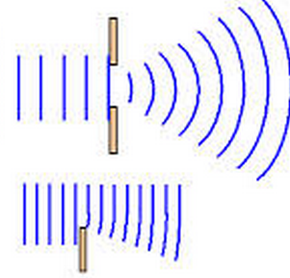

Diffraction - _____________ out of waves as they go through a _______ or around a _____________

Refraction – ______________ of waves, waves can get bent as they enter ________ _______________ (new ______________ = new ____________ = new ____________)

Resonance – the prolonging of a sound by several of __________ all _______________ at the _________ _________________
Interference – the ______________ of one wave with another wave
Constructive Interference (______________ reinforcement) – this is when two waves have the same ________________ and are moving in the same _______________, they ______ to one another and create a wave that has a bigger ________________________
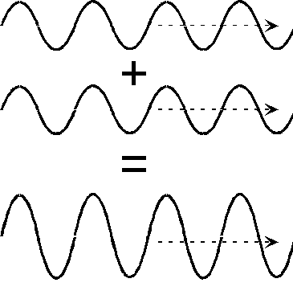
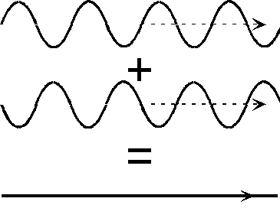
_________________ Interference (Negative reinforcement) – this is when two waves have the same __________________ and are moving in the same ____________, but the waves cycles are _____________ one another, they _____________ one another out
- This is how many of our noise canceling devices work

Doppler Effect: _________ getting _______________ as sound travels ______________ a ____________ and pitch getting _______________ as a sound source travels __________ from a listener
Think of it this way, if a bug is in the water and wiggles…

Ok, but what if the bug is moving at the same time toward one side?

Ok so what does this mean for us… think of an ambulance going past you…

