Assignment: 6
Name:_______________________________________________ Hour:___
Unit 4: Waves Test Review Sheet
Objective: Mechanical Waves
- Draw below pictures of the following waves AND label the important parts of each wave:
Transverse Longitudinal

- Describe what is happening in the picture below (be sure to use the terms particle, perpendicular, energy and amplitude).
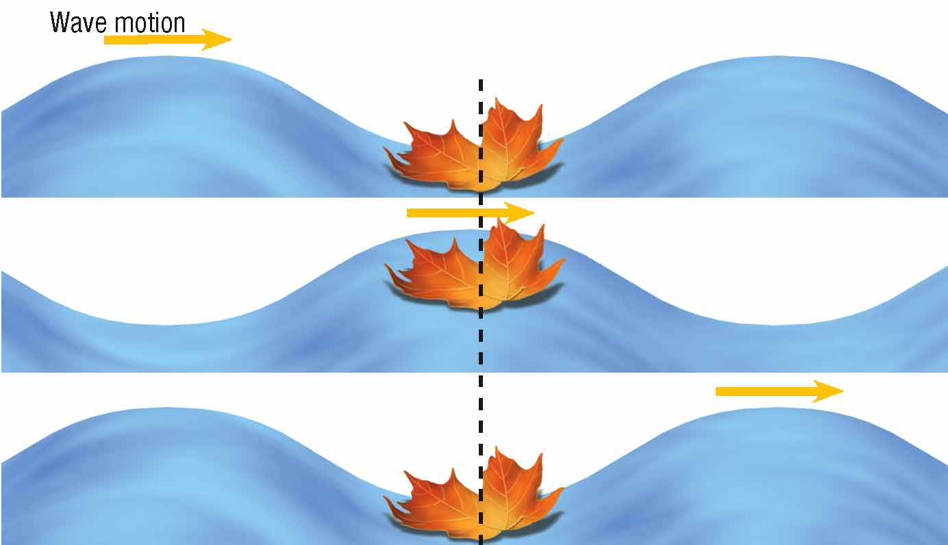
- Answer the questions about the following waves:
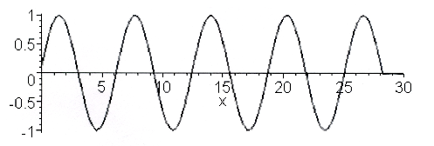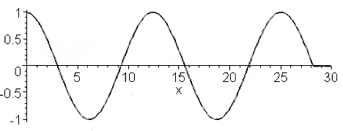

- What is the wavelength of the wave? _____
- What is the amplitude of the wave? ______
- If this is a snapshot that was taken in one second, what would the frequency be? ____
- What is the wavelength of the wave? _____
- What is the amplitude of the wave? ______
- If this is a snapshot that was taken in one second, what would the frequency be? ____

- Compare wave A and wave B, which one has a higher frequency? Which one has a lower frequency?
Objective: Sound Wave and Pitch
- What type of wave is sound an example of? What produces sound?
- What range of sound can humans hear? At what point will you experience pain and hearing loss?
- What state of matter does sound travel the fastest through and why? What about the slowest and why?
- What are the three ways you can change the pitch of a sound (think musical instrument)?
- When you think of a stringed instrument or the pipes on an organ, what is the relationship between the length of the string/pipe and the pitch of the sound it produces?
- How do dolphins or bats use sound waves to locate prey?
Objective: Wave Changes
- Match the following definitions with the correct vocabulary term
  - A wave changes direction as it passes through a new medium _________________________
  - The clashing of two waves, can be constructive or destructive _________________________
  - The bouncing back of waves when they hit a barrier _________________________
  - This is what we use padded panels, curtains and insulation to do in _________________________
the PAC so there is no echo of sound energy
Absorb Interference Refraction Reflection
Objective: Doppler Effect
- What is the Doppler Effect?
- Draw and explain an example of the Doppler Effect below.
Objective: Wave Calculations
- What are the units for the following variables?
  - Wavelength –
  - Frequency –
  - Wave speed –
- If a wave has a frequency of 100 Hz and a wavelength of 20 meters, what is its speed?
- A sound wave is moving through water and has a wavelength of 0.05 m and a frequency of 200 Hz, what is the speed of the wave?
- A wave travels the length of a guitar string and has a wavelength of 0.02 m and a frequency of 10 Hz, what is its speed?
- A sound wave travels in the air at 1000 m/s and has a wavelength of 0.4 m, determine the frequency of the wave.
- A wave travels through the water at 600 m/s with a frequency of 150 Hz, what is the waves length?

