Assignment: 4
Name: ________________________________ Hour:_____

Review Sheet – Unit 5 EM/Light

Light Matching/The Eye
_______________________ Particles of light are called this
_______________________ The path of light after it has been reflected
_______________________ The path of light as it travels to a surface
_______________________ States that the angle of incidence is equal to the angle of reflection
_______________________ The speed of this is faster than that of sound
_______________________ The clear, protective outer layer of the eye
_______________________ Caused due to an eyeball being too long and having a focus point before the retina
_______________________ The cells in the retina sensitive to colors
_______________________ The cell in the retina sensitive to low light
_______________________ A prism is an example of this that breaks white light into colors
_______________________ The change in direction of light as it travels from one medium to another
_______________________ Primary colors of light the eye detects
_______________________ This is the most common type of colorblindness that affects about 7% of males
_______________________ This is caused by light that passes through a filter that blocks light waves vibrating horizontally
_______________________ This part of your eye creates nerve impulses of images that will be sent to the optic nerve

Reflected ray Law of Reflection Cones Polarized Light Light
Red, green, blue Cornea Nearsightedness Retina Photons
Refraction Incident ray Rods Diffraction grating Red, green

Put the following in order or how light enters and travels through the eye: Retina, lens, cornea, pupil

Label the following parts of the eye:
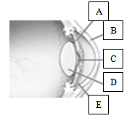

Lens vs Mirrors Matching

_______________________ Curved out mirror
_______________________ Curved in mirror
_______________________ Lens that is thicker in the middle than the ends
_______________________ Lens that is thinner in the middle and thicker at the ends

Convex Lens Concave Lens Convex Mirror Concave Mirror

Label the following as a mirror, prism or lens.

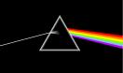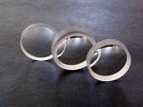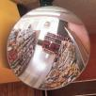

Label the following as a concave mirror, convex mirror, concave lens, convex lens.
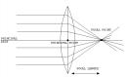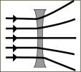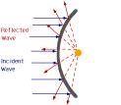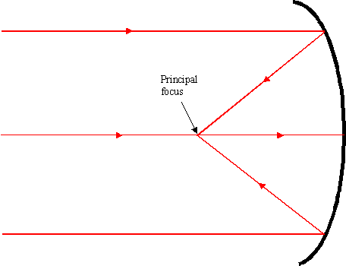

Electromagnetic Spectrum Matching

_______________________ The EM spectrum does not include this type of wave
_______________________ Used in communication and cooking
_______________________ Discovered by Roetegen in 1895, used to check for cracks in solid substances
_______________________ Beam of coherent light all one color used in supermarket checkouts
_______________________ Emitted from radioactive substances, very high frequency
_______________________ Used for entertainment, became common in the 1950s
_______________________ Marconi involved in discovering and using these waves around 1900
_______________________ Used to kill germs, can cause sunburn
_______________________ Used in remote controls, emitted from hot objects

Microwaves Ultraviolet X-rays Gamma rays Radio
Infrared Sound Laser Television

