Assignment: 6  
Name:_____________________________________ Hour:____  
 **Unit 3 Test – Review Sheet – Part 1**

**Objective: Potential and Kinetic Energy**

1. Define the following:
   1. Potential Energy –
   2. Kinetic Energy –
2. Give an example of the following:
   1. Potential energy changing into Kinetic energy –
   2. Kinetic energy changing into Potential energy -
3. Give examples of the following:
   1. Elastic Potential Energy –
   2. Gravitational Potential Energy –
4. If 2 Chainz (150 kg) and Justin Beiber (75 kg ) were standing on the edge of a diving board, who would have more potential energy? Who would have more kinetic energy?
5. Taylor Swift is writing another song about her ex-boyfriends, her fingers move 0.15 meters across her guitar traveling at a rate of 2 m/s, what is her kinetic energy?
6. What is the potential energy of the sponge lady’s 0.5kg sponge that is sitting on a table 4 meters from the ground?
7. Blake Shelton went hunting this past weekend in Michigan during open season, what is the kinetic energy if the rifle shot a 0.1 kg bullet moving with a velocity of 50 m/s?
8. Nelly is riding in his air force ones in a car that has a mass of 350 kg, it is moving at a rate of 50 meters per second, what is its kinetic energy?

**Objective: Work and Power**

1. What are the units for the following variables?
   1. Energy -
   2. Work -
   3. Power –
2. In each of the following situations is work being done?
   1. Nelly taking a ride with Florida Georgia Line down the road –
   2. 2 Chainz lifting his chains up from the floor –
   3. Zetterberg holding the Stanley cup trophy still for a picture –
   4. Verlander throwing a baseball to home plate –
3. Nelly is driving with Florida Georgia Line down the road, the car has a force of 500 N and travels 100 meters, how much work is done while they are cruising?
4. If Peyton Manning throws a ball with a force of 50 N and it travels 40 meters, how much work did he do?
5. If Peyton Manning does the throw described in the previous question above and it takes him 2 seconds to do so, how much power did he use?
6. If Jay Z hadn’t put a ring on it Beyonce would have used a force of 100 N to push his boxes 20 meters to the curb, how much work would she of done?
7. Rihanna and Eminem did 1,000 J work of work to scare away a monster in 5 seconds, what was their power output?
8. How much power is needed to pull a wrecking ball if you use 50 J of work in 10 seconds?

**Objective: Simple Machines and Mechanical Advantage**

1. What are three things that a machine CAN do to an applied force?
2. Define Mechanical Advantage –
3. Give at least two examples of the following simple machines:
   1. Lever –
   2. Pulley –
   3. Incline Plane –
   4. Wheel and Axle –
4. What is the mechanical advantage of a bike pedal and sprocket where the pedal radius is 20 inches and the front sprocket radius is 5 inches (pedal is the wheel, sprocket is the axle)?
5. What is a compound machine? Give an example.
6. Which incline plane would be the easiest for Macklemore to push his shopping cart full of thrift store finds up? Which would be the hardest? (note: the picture is not drawn to scale so you will need to do the math to find the MA for each with the data given)   
    a. [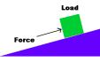](http://images.google.com/imgres?imgurl=http://kosmoi.com/Science/Physics/Machines/incline.gif&imgrefurl=http://kosmoi.com/Science/Physics/Machines/&h=197&w=316&sz=3&tbnid=qugitR0fPLeq9M:&tbnh=70&tbnw=113&hl=en&start=2&prev=/images%3Fq%3Dinclined%2Bplane%26svnum%3D10%26hl%3Den%26lr%3D%26sa%3DG) b. [](http://images.google.com/imgres?imgurl=http://kosmoi.com/Science/Physics/Machines/incline.gif&imgrefurl=http://kosmoi.com/Science/Physics/Machines/&h=197&w=316&sz=3&tbnid=qugitR0fPLeq9M:&tbnh=70&tbnw=113&hl=en&start=2&prev=/images%3Fq%3Dinclined%2Bplane%26svnum%3D10%26hl%3Den%26lr%3D%26sa%3DG) c. [](http://images.google.com/imgres?imgurl=http://kosmoi.com/Science/Physics/Machines/incline.gif&imgrefurl=http://kosmoi.com/Science/Physics/Machines/&h=197&w=316&sz=3&tbnid=qugitR0fPLeq9M:&tbnh=70&tbnw=113&hl=en&start=2&prev=/images%3Fq%3Dinclined%2Bplane%26svnum%3D10%26hl%3Den%26lr%3D%26sa%3DG) d. [](http://images.google.com/imgres?imgurl=http://kosmoi.com/Science/Physics/Machines/incline.gif&imgrefurl=http://kosmoi.com/Science/Physics/Machines/&h=197&w=316&sz=3&tbnid=qugitR0fPLeq9M:&tbnh=70&tbnw=113&hl=en&start=2&prev=/images%3Fq%3Dinclined%2Bplane%26svnum%3D10%26hl%3Den%26lr%3D%26sa%3DG)

Length= 15 Length= 50 Length= 16 Length= 28

Height= 2 Height= 5 Height= 4 Height= 2

1. 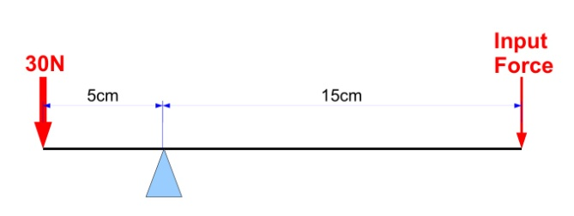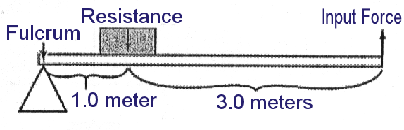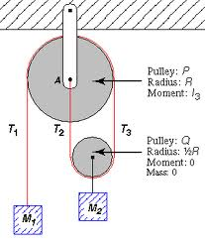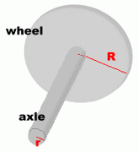What is the mechanical advantage of the following machines:

**MA =**

**MA =**

**MA =**

R=10  
r=2

**MA =**

**Objective: Machine Efficiency**

1. Define the following:
   1. Input –
   2. Output –
   3. Efficiency –
2. If a machine’s work input is 250 J and its work output is 100 J, what is its efficiency?
3. If a machine’s work input it 100 J and its work output is 50 J, what is its efficiency?