Name:___________________________ Hour:____
Unit 3 - Cardiovascular and Respiratory Systems Review Sheet

- I can explain how the parts of the cardiovascular system function.
- What is the main purpose/function of the cardiovascular system?
- If you break apart the word “Cardiovascular” what does it mean?
- What are the 5 main parts of the cardiovascular system?
- What is the function of blood vessels?
- There are three types of blood vessels, name all three below AND describe them.

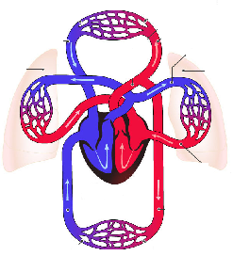
- I can label the parts of the cardiovascular system (heart, lungs, capillaries, veins, arteries, trachea, diaphragm, bronchi, bronchiole, alveoli).
- Label the following in the picture to the right:
Heart, Lungs, Capillaries, Veins, Arteries

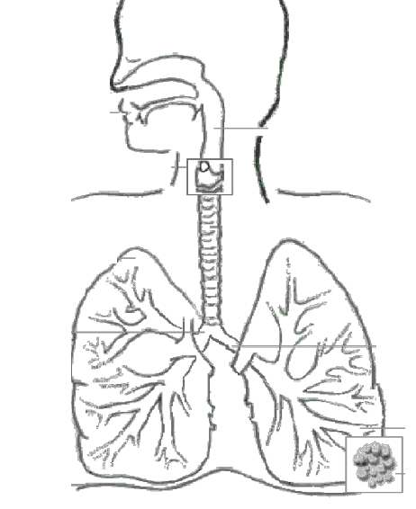
- Label the following in the picture to the right:
Trachea, Diaphragm, Bronchi, Mouth/Nose, Bronchiole, Alveoli

- Which picture, #6 or #7, shows the respiratory system? Which one shows the cardiovascular system?

- I can compare and contrast pulmonary vs. systemic circulation.
- What is the difference between pulmonary and systemic circulation?

- I can explain how oxygen enters the body and carbon dioxide leaves the body during respiration.
- What is respiration?

- In order for respiration to occur what two body systems have to work together?

- What is the main organ called that respiration takes place in?

- Fill in the blanks below in the description of how oxygen travels into our blood cells. Use the word bank below if needed.

The process of inhalation begins by the _____________, which is a muscle, contracts and draws air into the ____________ of a person. This air then travels down the _____________ which is a tube that connects the throat to the bronchi. At the end of the trachea it splits into two, this is known as the ________, which are tubes connecting the trachea to the lungs. The bronchi divide even further into the ____________ which distributes air throughout the lungs. At the end of the bronchioles are the _________, tiny sacs in the lungs where oxygen and carbon dioxide actually exchange.
Word Bank: Bronchioles Trachea Diaphragm Bronchi Alveoli Mouth/Nose

- I can describe the job of blood.
- What is the main purpose of blood?

- I can describe the parts of blood (red, white, platelets, plasma).
- What do the following parts of the blood do?
  - Red blood cells -
  - White blood cells -
  - Platelets -
  - Plasma -

- I can explain why capillaries need thin walls.
- Why do capillaries need to be so thin?

- What types of things get exchanged in the capillaries?

- I can explain the job of the heart.
- What is the main function of the heart?

- I can explain how blood pressure is required to move blood and I can discuss systolic vs. diastolic pressure.
- When you are measuring your blood pressure, what are you actually measuring?

- What is the difference between systolic and diastolic pressure?

