Assignment: 3
Name:_________________________________ Hour:______
The Eye
We have been studying all about light and the electromagnetic spectrum. The only part of the electromagnetic spectrum we can see with our naked eyes is visible light. But how does it actually travel into our eye? How do we see different colors/shades of things? What does it mean to be nearsighted or farsighted? You will discover the answers to these questions today.
- _________________________________
- _________________________________
- _________________________________
- _________________________________
- _________________________________
- _________________________________
- _________________________________
- Label the following parts of the eye.
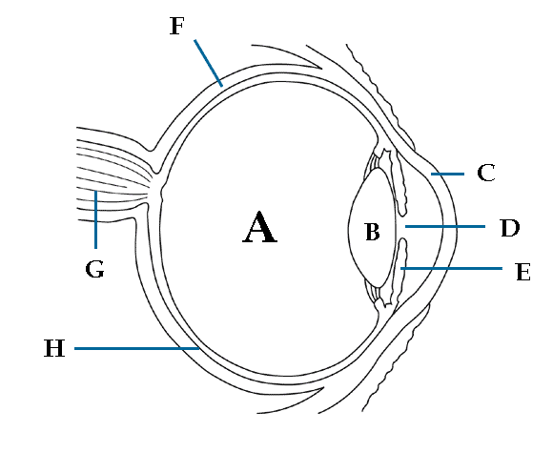
- What path does light take through the eye to create an image in your brain? Use the following terms in the correct order: lens, pupil, cornea, retina, optic nerve.

- Describe the following parts of your eye.
  - Cornea –
  - Pupil –
  - Lens –
  - Retina –
- Next to the following options put C if it describes a property of cones or a R if it describes a property of rods.
  - There are approximately 120 million in your eye ___________________________
  - There are approximately 6-7 million in your eye ___________________________
  - They are sensitive to low light ___________________________
  - They are sensitive to color ___________________________
  - They are centrally located in your eye ___________________________

- Fill out the following chart about the common eye problems.
 | Nearsightedness | Farsightedness
What is the other name it goes by?
What causes it?
What is the “problem” is causes to eye sight?

