Name: _______________________________________ Assignment:____
Review for standard PS1 Scientific Method
Study Guide; complete this review sheet, read/retake all your quizzes, Read through your homework/notes and circle or underline all key words, list the key words and write definitions for them, make a list of concepts/things to understand
Objective: Scientific Method
- Define the following:
  - Independent Variable –
  - Dependent Variable –
  - Control Group –
  - Constant –
  - Variable -
- Why is it important to have a control in your experiment? What is its purpose?
- How many independent variables should you have in your experiment and why?
- What is the general outline of the scientific method (ie… Question--- Conclusion)?
- What is the difference between a law and a theory?
- When thinking about the sample size of an experiment, what should the scientist try to do?
- What is the difference between accuracy and precision? Describe the difference using an example.
Ms. Pilarz wanted to see if changing the lighting in the classroom would affect the scores students would receive on tests. She typically leaves all the lights on for the test but began wondering if it was too bright to create a comfortable testing environment. She thought that if she only left half of the lights on students eyes would feel less strained and therefore have better test results. She randomly divided her classes into three groups. Group A took the test with all the lights on, Group B took the test with half the lights on, and Group C took the test with no lights on.
- What was Ms. Pilarz’s hypothesis?
- What was the independent variable of her experiment?
- What was the dependent variable of her experiment?
- What was the control group of her experiment?
- What were at least two errors she made or things she could do to improve her experiment?
- If she collected the following data, what would her conclusion be?
Type of Lighting | Average Test Score
All Lights On | 83%
Half the Lights On | 82%
No Lights On | 60%

Objective : Graphing
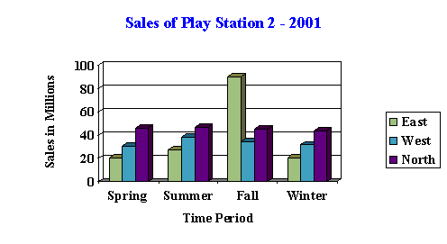
- When making a conclusion/analyzing data we often organize our information into tables and graphs, answer the following questions about the graph below.
  - What were the sales of PlayStation2 in the East during the fall?
  - What is the purpose of this graph?
- Below is a graph about the number of screaming goats in different countries, answer the following questions based on the graph.
Number of Screaming Goats
Number of screaming goats
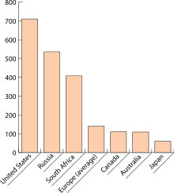
  - In what two counties did they have the same number of screaming goats?

  - What country has the most screaming goats, which country has the least?

- As people added pennies to their boat the density increased, draw a graph below with pennies on the x axis and density on the y axis to show this relationship.

Objective: Metric Units/Measurement
- Fill in the chart below:
 | Mass | Volume | Length
Base Metric Unit
Measured Using A…

Objective: Density
- What is the formula for density (need to memorize!)?
- Calculate the density of a block with dimensions 20 cm long, 5 cm high, 2 cm wide that has a mass of 50 grams (show your work).
- Using the liquid displacement method calculate the density of a 10 g marble that raises the water in a graduated cylinder from the initial volume of 21 mL to the final volume of 31 mL.
- What is the density of water?
- In order for an object to float, what must be true about its density?
- What does Archimedes Principle explain?
Objective: Rounding/Converting
- Round 37.5447 to the nearest thousandths
- Round 29.92 to the nearest hundredth
- How many kilometers are in 15 miles (hint 1 km = 0.6 mi)? SHOW YOUR WORK
- How many milligrams are in 250.5 decigrams?

