Assignment:____
Name:________________________________________________ Hour:____
Standard 8 Radioactivity- Review Sheet
Objective: Radioactivity Basics
- What is radioactive decay?
- Put the three types of decay we learned about in order from weakest to strongest. What will protect you from each type?
- Why is radiation harmful?
- Why is radiation helpful?
- Describe how the following terms relate to radiation:
  - Tracer –
  - Background radiation –
  - Geiger Counter -
Objective: Fusion vs. Fission
- What is the difference between fusion and fission?
- What do we mean when we say fission is like a chain reaction?
- Give an example of fusion and an example of fission.
- How have nuclear bombs been a part of United States history?
Objective: Nuclear Energy
- What type of decay do nuclear power plants use?
- Describe the safety features nuclear power plants have to avoid meltdown.
- Label the following parts in the picture below: Cadmium Control Rods, Uranium, Turbine, Generator, Cooling System
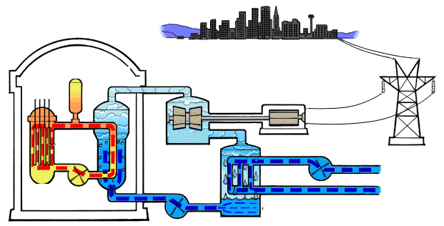
Objective: Half Lives
- What is a half life?
Carbon-14 is a radioactive isotope found in tissue from once living organisms. The half life of C-14 is 5,730 years. Use this information to answer the following questions.
- What is the age of a fossil that has 25% of carbon-14 left in it?
- How many half lives will pass by the time a 150g sample of carbon-14 decays into 4.69g?
- How many years does it take for a 150g sample of carbon-14 to decay to 37.5g?
- What percentage of a sample of C-14 remains after 11,460 years?
- How much of a 200g sample of C-14 will remain after 4 half-lives (give your answer in grams)?
Use the graph about Strontium-90 below to answer the following questions.
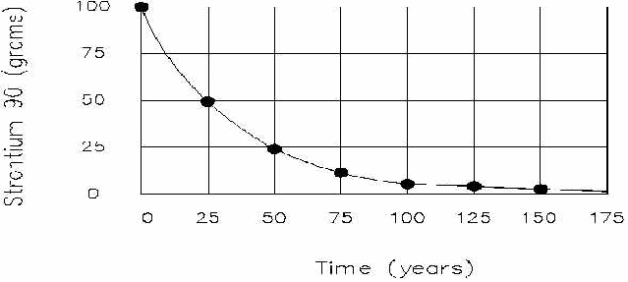
- What percent of Strontium-90 is left after 75 years?
- What is the half life of Strontium-90
- If you had 200g of Strontium-90, how much would be left after 25 years?
- If you had 500g of Strontium-90, how much would be left after 4 half lives?
- If you have 12.5% left of Strontium-90, how old is the sample?

