Punnett Practice

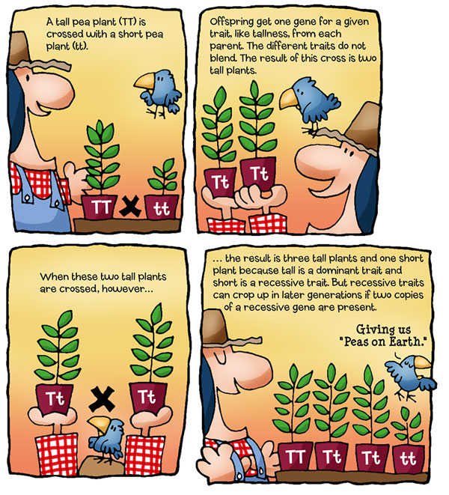

Name: ___________________________________ Hour: _____________

Write out the definitions for the following words:

Heterozygous:
Homozygous:
Dominant:
Recessive:
Genotype:
Phenotype:
Alleles:
Probability:
Monohybrid:
Dihybrid:
Law of segregation:
Law of independent assortment:

Complete the following monohybrid crosses (make the Punnett squares)
2 Chainz and Ms. P$ fall in love and get married. 2 Chainz, who raps-a-lot, is homozygous recessive for raps-a-lot disease and Ms. P$ is a heterozygous carrier for the disease. What is the probability of them having a child who suffers from raps-a-lot?
Probability of a child who raps-a-lot:

Beyonce and Jay-Z visit a genetic counselor to see if their child will have crazy in love syndrome. It is a dominant disorder and Beyonce is homozygous for it. Jay-Z does not carry the allele for it at all. What is the possibility that their child will have crazy in love syndrome? What is the probability that they will have crazy in love syndrome AND be heterozygous for the disorder?
Percent with “Crazy in Love”:
Percent with “Crazy in Love” AND Heterozygous:

Single Trait Inheritance Practice Problems
- In pea plants, for the trait of pod color, green pods are dominant (G) and yellow pods are recessive (g). Use a Punnett square to calculate the results of the cross of a heterozygous green pod plant with a homozygous yellow pod plant. What are the possible genotypes? What are the possible phenotypes?
Genotypes:

Phenotypes:

- White color (W) is dominant over yellow (w) in squash. If a heterozygous white fruited plant is crossed with a yellow fruited plant, show, using ratios the genotypes and phenotypes you would expect in the offspring.

Genotypes:

Phenotypes:
- The fictional, rare green blood disease is a homozygous recessive disease, nn. Normal blood is dominant (N). Green blood is recessive (n). Mr. and Mrs. Greengenes are both carriers (heterozygous) of this fatal disease. They have come to you, the world renowned geneticist, to determine the probability that one of their children may have this disease. Please, give them the entire story… What is the possibility that one of their children may be afflicted with this disease? What is the probability that one of their children will be a carrier? What is the probability that their kid little sprout will be totally normal?
Have the disease:
Carrier:
Totally Normal (not have it or be a carrier):

- Newlyweds, Dud and Chik, are very concerned that they both carry a gene for the recessive heavy metal disease. Dud has a sister who suffered from this disease and Chik’s aunt also suffered a loud, painful death from heavy metal. Dud is heterozygous for the disease and so is his chick, Chik. What is the probability that their child may suffer from this disease?

Probability of having the disease:
- The rare incurable laughing disease is a heterozygous disease. People with a heterozygous genotype will laugh themselves to death before age 18. Oopsy and his wife Poopsy are expecting their first bouncing bundle of joy. Oopsy is homozygous dominant for the trait and Poopsy is homozygous recessive for the trait. Please give them the news about the possibility of their child having the rare disease.

Give the news of the possibility of their child having it:

- Buckshot and his bride, Bobbie-gene, are thinking about having children. Buckshot suffers from a recessive genetic disease called mountain madness (mm). Bobbie-gene had a brother with mountain madness, so she figures that she is a carrier (heterozygous). Is there a possibility that they can have a child without the disease? What is the possibility of their child being a carrier? Is there any possibility of having a ‘normal’ child?
Without the disease:
Carrier:
‘Normal Child’:

- Jack and Diane fell in love and married. Both of them have had family members die from a disease called Cougar-Mellancamp Disease. If we assume they are both carrier of this obnoxious disease, what are the chances of Jack and Diane having a child with Cougar-Mellancamp Disease?

Chance they will have it:
Dihybrid Cross
- Use a Punnett Square to determine the genotypes and frequency of phenotypes of a dihybrid cross. Both parents are heterozygous for each trait. A tall plant with round seeds is crossed with another tall plant with round seeds. T (tall) is dominant over t (short) and R (round) is dominant over r (wrinkles). According to Mendel’s Law of Impendent Assortment, gametes will be distributed independently. The top box is started for you. Complete the top box and then do all of #2.
TtRr x TtRr

Genotypes: Phenotypes:
Description # Description
_________ ___ __________ ___
_________ ___ __________ ___
_________ ___ __________ ___
_________ ___ __________ ___
_________ ___
_________ ___
_________ ___ Phenotypic Ratio:
_________ ___ _____________
_________ ___
- In rabbits, black coat color is caused by a dominant gene (B) and brown is caused by its recessive allele (b). Curly hair is caused by a dominant gene (C) and straight hair is caused by its recessive allele (c). Cross a homozygous black, homozygous curly rabbit with a homozygous brown, homozygous straight haired rabbit. Summarize the F₁ and F₂ generations as to genotypes, and phenotypes, and phenotypic ratios.

Genotypes: Phenotypes:
Description # Description
_________ ___ __________ ___
_________ ___ __________ ___
_________ ___ __________ ___
_________ ___ __________ ___
_________ ___
_________ ___
_________ ___ Phenotypic Ratio:
_________ ___ _____________
_________ ___
Exceptions to Mendel Practice Problems

Incomplete Dominance
- A cross between a blue blahblah bird and a white blahblah bird produces offspring that are silver. The color of blahblah birds in determined by just two alleles.
  - What are the genotypes of the parent blahblah birds in the orgninal cross?

  - What is/are the genotypes of the silver offspring?

  - What would be the phenotypic rations of offspring produced by two silver blahblah birds?

- The color of fruit for a certain plant is determined by two alleles. When two plants with orange fruit are crossed the following phenotypic ratios are present in the offspring: 25% red fruit, 50% orange fruit, 25% yellow fruit. What are the genotypes of the parent orange-fruited plants? Red? Yellow?

Codominance
- A very common phenotype used in questions about codominance is roan fur in cattle. Cattle can be red (RR = all red hairs), white (WW = all white hairs) or roan (RW = red and white hairs together). Predict the phenotypic rations of offspring when a homozygous white cow is crossed with a roan bull.

- What should the genotypes and phenotypes for parent cattle be if a farmer wanted only cattle with red fur?

Multiple Alleles
- A woman with Type O blood and a man who is Type AB are expecting a child. What are the possible blood types of the kid?

- What are the possible blood types of a child whose parents are both heterozygous for B blood type?

Polygenic Traits
- Explain polygenic traits.

- Give at least 2 examples of a polygenic trait

