Assignment Number______
Name:___________________________________ Hour:______
Why do we have DNA?
It is a set of _________________________________ that tells our cells/bodies how to _____________________
How does DNA create action?
It contains information on how to make _____________________ (proteins do the actual ____________ in a cell)
How does protein come from DNA?
The process of _____________________ __________________________
BIG IDEA

Protein Synthesis: From Gene to Protein

Key Players

Key Processes

Key Players in RNA
- Nucleic Acid
- Structure –similar to DNA
- Made up of _______________________
  - Sugar ( ____________________)
  - Phosphate Group
  - Base ( ____ , ____ , ____ or ____)
- Bases attach to ______________________
Compare and Contrast DNA vs RNA

DNA
- ___________________ (T)
- _____ strands
- 4 oxygens per sugar (______________________)
- Must STAY in the ___________________
RNA
- Uracil (____)
- ____ strand
- 5 oxygens per sugar (_______________)
- Can _____________________ the nucleus
Three Types of RNA
- mRNA - ___________________ - takes genetic information out of the nucleus
- tRNA - ____________________ - carries amino acids to mRNA
- rRNA - ____________________ - makes up ribosomes
Protein Synthesis
Transcription – making an ______ copy from _______
Remember: ______________ (U) replaces __________________ (T)
- DNA unzips in small portions and is read by _______ ________________________
- RNA _______________________ attach in a ______________________________ sequence to make a chain of RNA
- The termination site on the _______ tells the ______ polymerase to detach from the DNA
- The new chain of _______ nucleotides is called ____________ and can now leave the ___________________
Translation – three types of RNA working together to make _____________ using ________________ ___________
Important Terms
Codon – set of _____ bases on mRNA
Anti-codon – set of ____ bases on ________ (complimentary to a codon)
- __________ leaves the ________________ and attaches to ______________________ (ribosomes are in 2 parts)
- Ribosomes read ________ one _____________ at a time
- __________ with the matching anti-codon attaches, bringing with it an ______________ _______
- _____________ attaches its _____________ ____________ to the previous amino acid and then _______________
- Long chains of amino acids are made. A long chain of amino acids is a __________________
- The _____________ ________________ ends protein synthesis and the new protein leaves the ribosome
- The _______________ determine our traits and also do all the ____________ in our cells

Important Terms:
Stop Codon – tells tRNA to _________ making the _____________. Signals the end of a chain of amino acids.
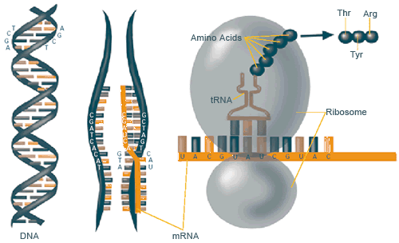
Initiator – the _____________ _______________ in a sequence of mRNA. Tells tRNA where to ___________ making a protein

Secret Code Practice:
Original Strand –

mRNA Strand -

Practice:
Transcribe this strand of DNA: ATTACGATCTGCACAAGATCCT
Translate the mRNA you made above:

