Assignment:___
Name:_____________________ Hour:____
Common Polyatomic Ions
Ionic Compounds:

Figuring out the formula:

Figuring out the name:

Given the name, finding the formula:
NH₄¹⁺ | ammonium
NO₃¹⁻ | nitrate
NO₂¹⁻ | nitrite
ClO¹⁻ | hypochlorite
ClO₂¹⁻ | chlorite
ClO₃¹⁻ | chlorate
ClO₄¹⁻ | perchlorate
OH¹⁻ | hydroxide
CN¹⁻ | cyanide
C₂H₃O₂¹⁻ | acetate
MnO₄¹⁻ | permanganate
CO₃²⁻ | carbonate
HCO₃¹⁻ | bicarbonate (hydrogen carbonate)
SO₄²⁻ | sulfate
SO₃²⁻ | sulfite
HSO₄¹⁻ | bisulfate
HSO₃¹⁻ | bisulfite
CrO₄²⁻ | chromate
Cr₂O₇²⁻ | dichromate
O₂²⁻ | peroxide
C₂O₄²⁻ | oxalate
PO₄³⁻ | phosphate
HPO₄²⁻ | hydrogen phosphate
H₂PO₄¹⁻ | dihydrogen phosphate
SiO₄⁴⁻ | silicate

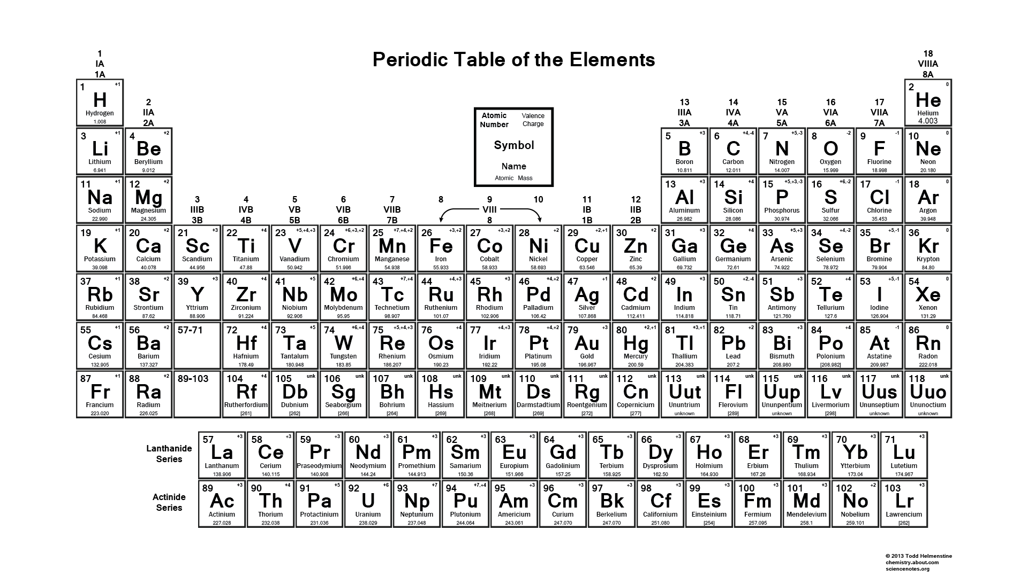
3+ 4+/- 3- 2- 1- Stable
2+
1+
