Name:______________________________________ Hour:_____
Exam Study Guide – Physical Science – Chemistry Semester
Unit 6 – Properties of Matter
Terms to know:
Matter Element Chemical change Physical change
Solvent Solute Heterogeneous mixture Homogeneous mixture
Colloid Gel Aerosol Emulsion
Pure substance Mixture Compound Solubility
- What does all matter contain?

- Draw a picture showing the arrangement of atoms in each of the four states of matter below.
Solid Liquid Gas Plasma

- Add to your pictures above, what it is called as you switch between the different states of matter (for example solid->liquid = melting)
- What is the difference between a chemical change and a physical change? Include some examples of each.
- Define the following:
  - Element –
  - Compound –
  - Mixture –
- What is the difference between a homogenous mixture and a heterogeneous mixture?

- Fill in the chart below about the different types of colloids:
Colloid | Describe what it is made out of | Examples
Aerosol
Emulsion
Gel
- When talking about solutions we can describe them based on the amount of solute to solvent they have, describe the following:
  - Unsaturated Solution -
  - Saturated Solution -
  - Supersaturated Solution -
Hint: I might revisit the solubility graph practice we did during this unit, see your notebook.
Unit 7 – Atomic Theory and the Periodic Table
Terms to know:
Atom Proton Neutron Electron
Subatomic particles Nucleus Malleable Ductile
Energy level Valence electron Ion Isotope
Semiconductor Atomic mass Atomic number Symbol
- What are the two parts of an atom? What is found in each part? Which part occupies the majority of the space? Which part contains the majority of the mass?

- In addition to knowing where they are (in the previous question), what are the charges of the following subatomic particles?
  - Protons –
  - Neutrons –
  - Electrons –
- What does the atomic mass of an element represent?
- What is different about isotopes of the same element?
- What are ions?
- Fill out the following chart practicing how to figure out subatomic particles and basics about elements:
Element | Symbol | Atomic Number | Atomic Mass | Protons | Neutrons | Electrons
Boron
Calcium
Gold
Argon
C-14
C-12
O-16
O-18
Li ¹⁺
O²⁻
Mg²⁺

- What are valence electrons?
- When thinking about Bohr models, how many electrons fit in each energy level?
- How many valence electrons would the following elements have?
  - Oxygen –
  - Carbon –
  - Magnesium –
- If an ion has a positive charge what does that mean? What if it has a negative charge?
- Who organized the periodic table?

- On the table below, label the following: alkali metals, alkaline earth metals, transition metals, metalloids, non-metals, halogens, noble gases
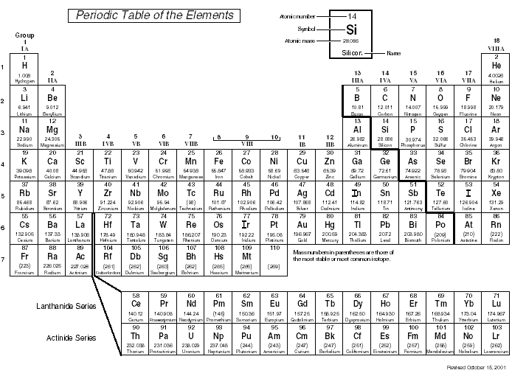
- What makes noble gases so unique?
- Describe the basic properties of the following:
  - Metals –
  - Non-metals –
  - Metalloids –
- Metals have several unique properties, describe the following:
  - Ductile –
  - Malleable –
  - Conductive –
Unit 8 - Radioactivity
Terms to know:
Fusion Fission Geiger counter Radiation
- Describe the difference in strength between the following types of radiation:
  - Alpha radiation –
  - Beta radiation –
  - Gamma radiation –
- Create a chart below comparing and contrasting fusion and fission.
- When dealing with nuclear power plants, what are some ways we control the rate of reaction/prevent meltdowns?
- What is a half life?
- Carbon-14 has a half life of 5,730 years. Supposed you had a fossil with 75% of its original C-14 already decayed, how old would you suspect the fossil is?
- Use the chart below to answer the following questions:
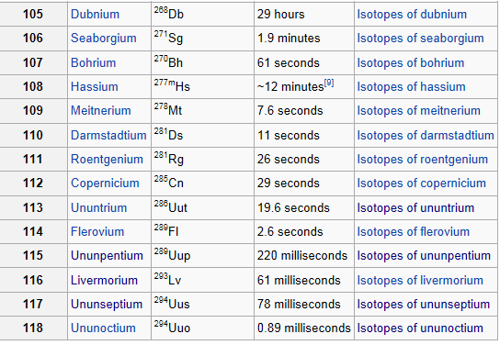
  - If I start with 10 grams of Bh-270, how much would I have left after 183 seconds?
  - Which element would have 87.5% of its sample decay in 7.8 seconds?
  - If I have Db-268 and only 25% of it remains undecayed, how many half lives have happened? How long would this have taken?

- What does it mean for an atom to be stable?
Unit 9A – Compounds, Naming and Bonding
Terms to know:
Ions Ionic Bond Covalent Bond Product
Reactant Formula Mass Atomic Mass Percent Composition
- Answer the following based on the equation below:
6CO₂ + 6H₂O C₆H₁₂O₆ + 6O₂
  - What are the reactants?
  - What are the products?
  - How many hydrogen atoms are on the reactants side?
  - How many hydrogen atoms are on the products side?

- Answer the following based off of the formula below:
NH₃
  - How many atoms of each element are there?
  - What is the molecular mass (formula mass)?
  - What is the percent composition of hydrogen?

- Answer the following based off of the formula below:
H₂SO₄
  - How many atoms of each element are there?
  - What is the molecular mass (formula mass)?
  - What is the percent composition of hydrogen?

- What is the difference between an ionic bond and a covalent bond?

- What formula would the following ions create? (hint: think boogie method)

  - Ag ⁺¹ NO₃ ⁻¹

  - Na ⁺¹ Cl ⁻¹

  - Ca ⁺² Cl⁻¹

  - Sn ⁺⁴ N⁻³

- Name the following formulas, keep in mind there are different naming rules for ionic and covalent compounds (hint this is something you may want to write on your notecard)

  - BaCl₂
  - K₂S
  - SO₂
  - MgO
  - NaF
  - P₄S₅
  - SeF₆

- Given the following names, write the formulas (again these are a mix of ionic and covalent, keep in mind with ionic you may need to balance out charges… covalent will tell you subscripts in the name)
  - Iodine pentafluoride
  - Copper (II) chloride
  - Lithium oxide
  - Dinitrogen trioxide
  - Phosphorus triiodide
  - Barium fluoride
  - Lithium acetate
Unit 9B – Reactions and Stoichiometery
Terms to know:
Products Reactants Synthesis Decomposition
Single Replacement Double Replacement Exothermic Endothermic
Moles Molecules Mass Avogadro
- Describe the following reactions in basic terms using letters (first one is done for you)
  - Synthesis – A +B AB
  - Decomposition –
  - Single Replacement –
  - Double Replacement –
- Identify the following reactions as one of the types you defined in #1 above:
  - CH₄ + Cl -----> CH₃Cl + HCl
  - 3Fe + 2O₂ ------> Fe₃O₄
  - Zn(OH)₂ + 2HCl ------> ZnCl₂ + 2H₂O
  - H₂O H₂ + O
- Balance the following equations

___Mg + ___N₂ ___Mg₃N₂

___N₂ + ___O₂ ___NO₂

___HgO ___Hg + ___O₂

___Cu + ___S ___Cu₂S

___NO₂ ___N₂ + ___O₂

___Fe + ___O₂ ___Fe₂O₃

___H₂O ___H₂ + ___O₂

___NH₃ ___N₂ + ___H₂

- How many moles are in 10 grams of Beryllium?
- How many grams are in 5 moles of Nitrogen?
- How many moles are in 25 grams of AgNO₃?
- How many grams are in 3 moles of Cr₂O₃?
- How many molecules are in 5 grams of water (H₂O)?
- How many grams are in 2.5 x10²⁴ molecules of water (H₂O)?
- Contrast exothermic and endothermic reactions below using a chart, include a sketch of what a graph of each looks like.
Unit 9C – Organic Chemistry
Terms to know:
Organic Hydrocarbon Alkane Alkene
Alkyne Isomer Functional Group
- What makes carbon so special when it comes to bonding?
- What is a basic property of all hydrocarbons?
- What is the difference between an alkane, alkene and alkyne?
- Name the following:
  - CH₃ – CH₂ - CH₂ - CH₃
  - CH₃ – CH₂ - CH₂ - CH₂ - CH₂ - CH₂ - CH₃
  - C=C-C-C-C-C
  - C=C-C
  - CH₄
- What are isomers?
- What are functional groups?
Unit 10 – Acids and Bases
Terms to know:
Acid Base pH scale Neutralization
Indicator Litmus paper Acid Rain pH
- Create a chart below comparing acids and bases.

- What is the pH of a solution with a H+ concentration of 1.0 x 10⁻⁵ M?

- Is a solution with a H+ concentration of 11.2 x 10⁻¹⁰ M acidic, basic or neutral?
- What is the concentration of 4 moles of HCl in 2 L of water?
- What is the concentration of 2.5 moles of HCL in 4000 ml of water?
- How much 0.5 M HCl solution can be made by diluting 2L of 12 M HCl?

