Name:____________________________________ Assignment:___
pH Test Review
pH Basics
- What is pH?
- We measure pH using indicators, what is an indicator?
- What are some examples of indicators?
pH Scale
- Create number line below going from 1-14….
  - Put a star where the strongest acid would be
  - Put a heart where the strongest base would be
  - Put an square where neutral would be

- Name at least three examples of the following:
  - Acids –
  - Bases –
  - Neutral s –
- What happens when you mix an acid and a base together?
- What happens if you mix ammonia and bleach together?
Acids vs. Bases
- Create a chart below comparing acids and bases, be sure to include how they taste, feel, what to look for in their chemical formulas and what types of ions they contain

Chemical Formulas
- Match the following:
________ Hydrochloric Acid H₂SO₄
________ Nitric Acid HCl
________ Sulfuric Acid NaOH
________ Acetic Acid NH₃
________ Potassium hydroxide KOH
________ Ammonia HC₂H₃O₂
________ Sodium hydroxide HNO₃
Acid Rain
- What is acid rain?
- Why are some lakes more or less affected that others by acid rain?
pH Calculations
- What is the pH of a solution with a H+ concentration of 2.0 x 10⁻⁵?
- If the H+ concentration of a solution is 5.6 x 10 ⁻¹⁰ what would be its pH and would it be an acid, base or neutral?
- What is the concentration of a solution that is 4 moles of NaOH in 2L of water?
- What is the concentration of a solution that is 13.5 moles of KOH in 3,000 mL of water?
- How much of 0.5 M KOH can be made by diluting 2.5L of 20 M KOH?
pH Data

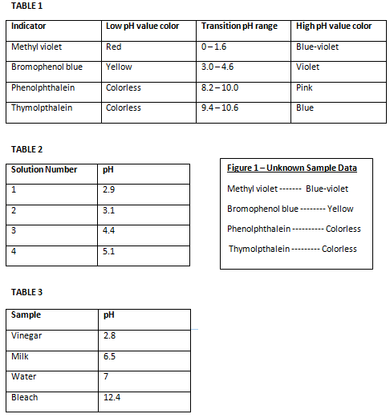
- Using Tables 1 and 2, which solution turned the bromophenol blue pH paper violet?

- A drop of bleach is placed on a strip of bromophenol blue pH paper. Using Tables 1 and 3, what color does it turn?

- What kind of pH indicator paper would allow the student to distinguish between his vinegar sample and his water sample?

- The student applies a drop of each household sample from Table 3 to a strip of thymolpthalein pH paper. Which household sample listed turns the paper blue?

