Organic Chemistry

An Introduction
by Anthony Carpi, Ph.D.
To understand life as we know it, we must first understand a little bit of organic chemistry. Organic molecules contain both carbon and hydrogen. Though many organic chemicals also contain other elements, it is the carbon-hydrogen bond that defines them as organic. Organic chemistry defines life. Just as there are millions of different types of living organisms on this planet, there are millions of different organic molecules, each with different chemical and physical properties. There are organic chemicals that make up your hair, your skin, your fingernails, and so on. The diversity of organic chemicals is due to the versatility of the carbon atom. Why is carbon such a special element? Let's look at its chemistry in a little more detail.
- What elements are always in organic molecules?
- Why are organic molecules so important?

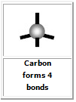
Carbon (C) appears in the second row of the periodic table and has four bonding electrons in its valence shell. Similar to other non-metals, carbon needs eight electrons to satisfy its valence shell. Carbon therefore forms four bonds with other atoms (each bond consisting of one of carbon's electrons and one of the bonding atom's electrons). Every valence electron participates in bonding, thus a carbon atom's bonds will be distributed evenly over the atom's surface. These bonds form a tetrahedron (a pyramid with a spike at the top), as illustrated below:
- Why does carbon want to form 4 bonds?

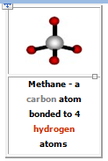
Organic chemicals get their diversity from the many different ways carbon can bond to other atoms. The simplest organic chemicals, called hydrocarbons, contain only carbon and hydrogen atoms; the simplest hydrocarbon (called methane) contains a single carbon atom bonded to four hydrogen atoms:
- What is a hydrocarbon?

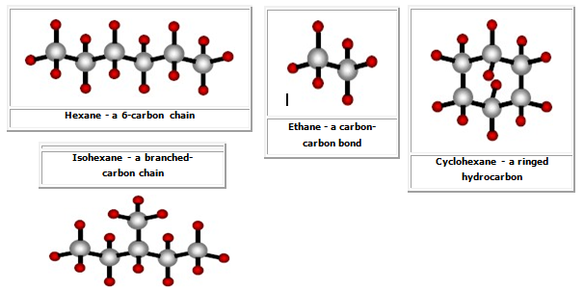
But carbon can bond to other carbon atoms in addition to hydrogen, as illustrated in the molecule ethane below. In fact, the uniqueness of carbon comes from the fact that it can bond to itself in many different ways. Carbon atoms can form long chains, branched chains, and rings.

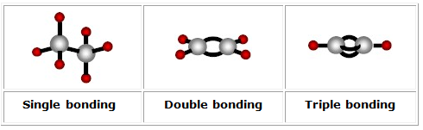
There appears to be almost no limit to the number of different structures that carbon can form. To add to the complexity of organic chemistry, neighboring carbon atoms can form double and triple bonds in addition to single carbon-carbon bonds:
Keep in mind that each carbon atom forms four bonds. As the number of bonds between any two carbon atoms increases, the number of hydrogen atoms in the molecule decreases (as can be seen in the figures above).
- What type of arrangements can carbon molecules form? What types of bonds can carbon form?

- Why do the number of hydrogen atoms decrease when the number of bonds between any two carbon atoms increase?

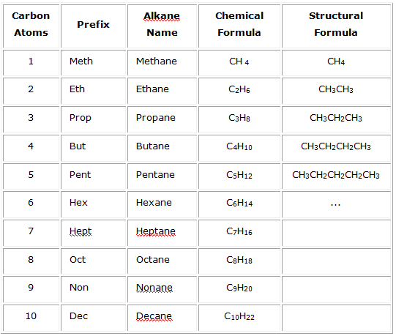
Alkanes
The simplest hydrocarbons are those that contain only carbon and hydrogen. These simple hydrocarbons come in three varieties depending on the type of carbon-carbon bonds that occur in the molecule. Alkanes are the first class of simple hydrocarbons and contain only carbon-carbon single bonds. The alkanes are named by combining a prefix that describes the number of carbon atoms in the molecule with the root ending "ane". The names and prefixes for the first ten alkanes are given in the following table.
The chemical formula for any alkane is given by the expression C_{n}H_{2n+2}. The structural formula, shown for the first five alkanes in the table, shows each carbon atom and the elements that are attached to it. The simple alkanes share many properties in common. All enter into combustion reactions with oxygen to produce carbon dioxide and water vapor. In other words, many alkanes are flammable.
This makes alkanes good fuels. For example, methane is the principle component of natural gas, and butane is common lighter fluid.
- What is important/unique about alkanes?
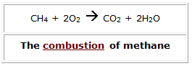
Alkenes
The second class of simple hydrocarbons, the alkenes, consists of molecules that contain at least one double-bonded carbon pair. Alkenes follow the same naming convention used for alkanes. A prefix (to describe the number of carbon atoms) is combined with the ending "ene" to denote an alkene. Ethene, for example is the two- carbon molecule that contains one double bond. The chemical formula for the simple alkenes follows the expression C_{n}H_{2n}. Because one of the carbon pairs is double bonded, simple alkenes have two fewer hydrogen atoms than alkanes.
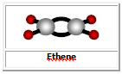
- What is an Alkene? How is it different than an alkane?
Alkynes
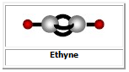
Alkynes are the third class of simple hydrocarbons and are molecules that contain at least one triple-bonded carbon pair. Like the alkanes and alkenes, alkynes are named by combining a prefix with the ending "yne" to denote the triple bond. The chemical formula for the simple alkynes follows the expression C_{n}H_{2n-2}.
- How is an Alkyne different than alkanes and alkenes?

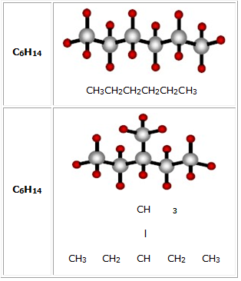
Isomers
Because carbon can bond in so many different ways, a single molecule can have different bonding configurations. Consider the two molecules illustrated here:
Both molecules have identical chemical formulas (shown in the left column); however, their structural formulas (and thus some chemical properties) are different. These two molecules are called isomers. Isomers are molecules that have the same chemical formula but different structural formulas.
- What is an isomer? Give an example

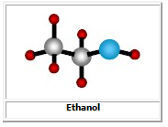
Functional Groups
In addition to carbon and hydrogen, hydrocarbons can also contain other elements. In fact, many common groups of atoms can occur within organic molecules, these groups of atoms are called functional groups. One good example is the hydroxyl functional group. The hydroxyl group consists of a single oxygen atom bound to a single hydrogen atom (-OH). The group of hydrocarbons that contain a hydroxyl functional group is called alcohols. The alcohols are named in a similar fashion to the simple hydrocarbons, a prefix is attached to a root ending (in this case "anol") that designates the alcohol. The existence of the functional group completely changes the chemical properties of the molecule. Ethane, the two-carbon alkane, is a gas at room temperature; ethanol, the two-carbon alcohol, is a liquid.
Ethanol, common drinking alcohol, is the active ingredient in "alcoholic" beverages such as beer and wine.
- What are functional groups? Give an example.

