Assignment: _____
Name:_____________________________ Hour:_________

Observations vs Inferences AND Qualitative vs Quantitative

Observation:

Inference:

Read/look at the following examples and make an observation and an inference about each:

- You look outside and the grass is wet. Observation:

Inference:

- The principal interrupts class and calls a student to the hallway.
Observation:

Inference:

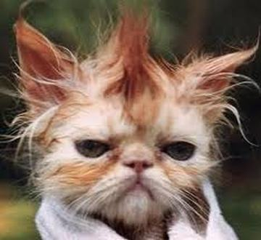
Observation:

Inference:

Qualitative observations:

Quantitative observations:

Read the following examples and then decide if the example is qualitative (1) or quantitative (2).
1. It is light green in color. ________ (1 or 2)
2. It taste sour. ______ (1 or 2)
3. One leaf is 9 cm long. ____ (1 or 2)
4. It makes a loud pop sound. ____ (1 or 2)
5. The mass of the computer is 1 1/2 kg. ____ (1 or 2)
6. It smells sweet. ____ (1 or 2)
7. The temperature of the room increases by 8 degrees C. ____ (1 or 2)
8. The flower clusters in 3 blooms. ____ (1 or 2)
9. Leaves are stiff. ____ (1 or 2)
10. The veins are 3 mm wide. ____ (1 or 2)

Write a qualitative example:

Write a quantitative example:

What type of observation (qualitative or quantitative)do you think is more scientific and why?
Practice Page (on your own):

Determine which of the following statements are quantitative and which are qualitative.
1. _____________ The cup had a mass of 454 grams.
2. _____________ The temperature outside is 250 C.
3. _____________ It is warm outside.
4. _____________ The tree is 30 feet tall.
5. _____________ The building has 25 stories.
6. _____________ The building is taller than the tree.
7. _____________ The sidewalk is long.
8. _____________ The sidewalk is 100 meters long.
9. _____________ The race was over quickly.
10. _____________ The race was over in 10 minutes.

CONSTRUCTING INFERENCES FROM OBSERVATIONS
Which of the following statements are observations and which are inferences? Indicate your answer with either the letter “O” for an observation, or the letter “I” for an inference.
1. _____________ It is summertime.
2. _____________ It is daytime.
3. _____________ They saw birds.
4. _____________ They saw seagulls.
5. _____________ They went swimming.
6. _____________ One friend’s name was Bob.
7. _____________ It was a warm day.
8. _____________ The birds were black and white.
9. _____________ They ate lunch and drank Coca-Cola&.
10. _____________ The people are friends.

