Name:_________________________________________ Assignment:_______
Metric Converting
Let’s start simple… place value.

Rules for rounding:

Rounding practice:
Number: Round to: Answer:
19.756 Nearest hundredth ____________________
14.872 Nearest tenth ____________________
17.555 Nearest thousandth ____________________
12.342 Nearest tens ____________________
14.456 Nearest tenth ____________________
Metric Mania – Metric Conversion Ladder Method
Ladder Method: Fill in the ladder below
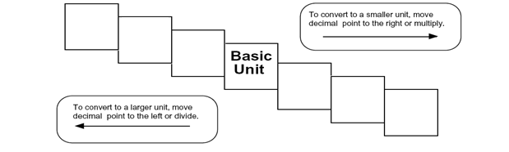
How do you use the “ladder” method?
1st – Determine your starting point and ending point
2nd – Count the “jumps” to your ending point
3rd – Move the decimal the same number of jumps in the same direction

Example:
4km = ________________m How many jumps does it take?

Conversion Practice
Try these conversions using the ladder method:

1000 mg = ________ g
14 km = ________m
1 L = ________ mL
109 g = ________ kg
160 cm = ________mm
250 m = ________km

Compare using <, > or =

56 cm ________ 6 m
7 g ________ 698 mg

Write the correct abbreviation for each metric unit

- Kilogram _____
- Meter _____
- Gram _____
- Milliliter _____
- Millimeter _____
- Liter _____
- Kilometer _____
- Centimeter _____
- Milligram _____

Conversion Practice

- 2000 mg = _____ g
- 104 km = _____ m
- 480 cm = _____ m
- 5.6 kg = _____ g
- 8 mm = _____ cm

Compare using <, > or =

- 63 cm _____ 6 m
- 536 cm _____ 53.6 dm
- 5 g _____ 508 mg
- 43 mg _____ 5 g
- 1,500 mL _____ 1.5 L
- 3.6 m _____ 36 cm

Metric Converting Practice (on your own!!):
Give the missing decimals
1) 3 mm = _______cm 5) 6 cl = ________l 9) 25 cg =________g
2) 5cm = _______dm 6) 7 dl = ________dkl 10) 15g=________kg
3) 6dm= _______m 7) 9l= ________hl 11)32dg=________kg
4) 8m = ________dkm 8) 4ml= ________l 12) 98cg =________g
Give the missing number
13) .3cm = _______mm 17) .06l = ________cl 21) .27g=________mg
14) .6m = _______dm 18) .08dkl = ________dl 22).15g=________mg
15) .4hm= _______dkm 19) .09hl= ________l 23).052 dkg=_______cg
16) .9km = ________hm 20) .002l= ________ml 24).22hg=________g

