Assignment: 4
Name:__________________________ Hour:____
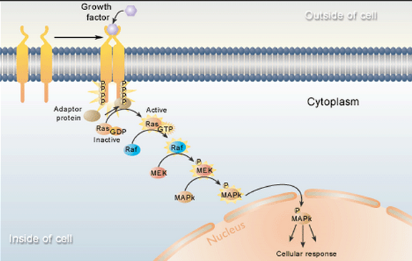
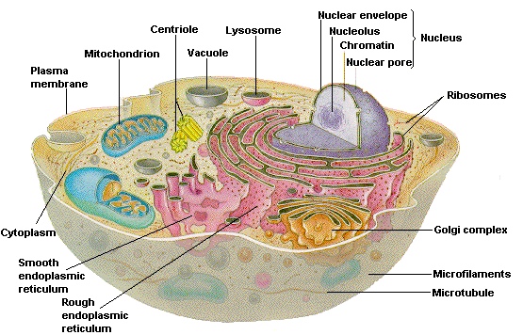
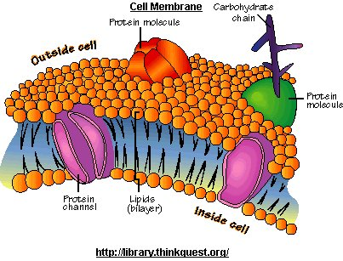
Review – Parts of the Membrane
Let’s zoom into the cell membrane
Phospholipids:

Channel Proteins:

Marker Proteins:

Receptor Proteins:

Movement across the Membrane
- Cell membranes are _____________________ _________________ which means they have the ability to choose what goes into and out of the cell
Passive Transport: __________ to _________ with the concentration gradient
- Diffusion:

- Osmosis:
Three types of environments that cells can be placed in:
Hypertonic Hypotonic Isotonic

Equilibrium:
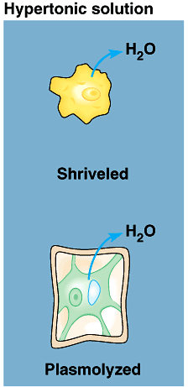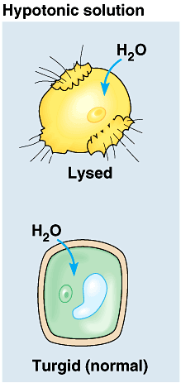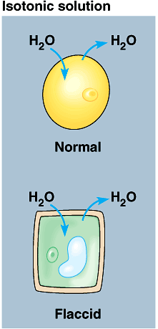
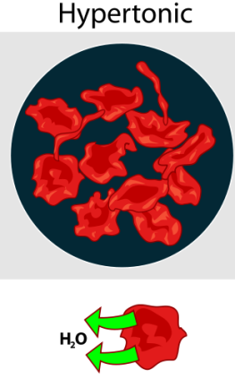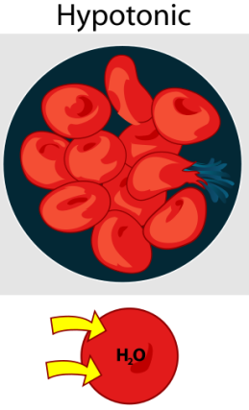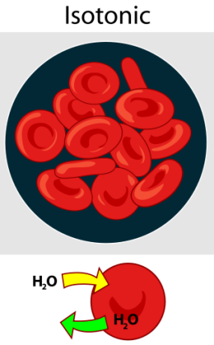
Active Transport: _________ to __________ against the concentration gradient, requires _____
- Active Transport:
Other types of movement across the membrane…
Exocytosis -
Endocytosis –
Phagocytosis –
Pinocytosis -

