Assignment: 2
Name:_______________________________________ Hour:___
Membrane Notes Day 1
Cell (Plasma) Membrane
Cells need an inside and an outside…
- Separate cell from its environment
- _________________________________________________

In
- __________
  - Sugars
  - Proteins
  - Fats
- Salts
- O₂
- H₂O
Out
- __________
  - Ammonia
  - Salts
  - CO₂
  - H₂O
- ____________________
  - Proteins

Cell Membrane Functions
- Allow things to __________
- Keeps material _______
- Holds ___________ ______________ to help cells ______________ each other
- Allow cells to ________________ _________________ and respond to their __________________

Lipids of Cell Membrane
Membrane is made of a special kind of ____________ that is the _______ _________________ _______
- ________________________
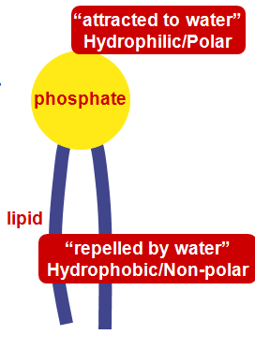
- “Split personality”
Membrane is a __________ layer
- _________________ _________________

Selectively (_______ - _________________) Membrane
Cell membrane controls what gets in or out
Need to allow ________ materials – but not all – to pass through the membrane
- Selectively (semi-permeable)
  - _______________________________________________________ _______________________________________________________

Crossing the Cell Membrane
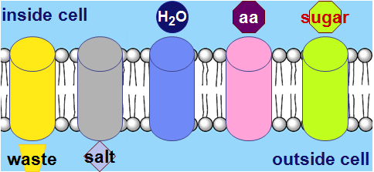
What molecules can get through the cell membrane directly?
- __________________________________________________________

Cell Membrane Channels
Need to make “doors” through membrane
- ______________ __________________ allow substances ____ and ______
  - ____________ _____________ allow ________________ _______________ in and out
  - H2O channel, salt channel, sugar channel, etc.

Proteins are an anchor molecule

Within membrane
- ___________ amino acids
  - ________________
  - Anchors protein into membrane
On outer surfaces of membrane
- ____________ amino acids
  - ______________
  - Extend into extracellular fluid (between cells) and into cytoplasm

Protein Channels
Proteins act as ____________ in the membrane
- ______________ to move _______________ _________________ through cell membrane

Molecules move from high to low
_____________________
- Move from __________ to _________ concentration
_____________________ _____________________
- Having a _________ and _______ concentration of _________ in a ________________

Vocabulary
A solution is made of two parts:
- Solute – what gets ________________ in a solution
- Solvent – what does the _____________________, typically the __________
Examples:
- Kool-Aid Solute: Solvent:
- Salt Water Solute: Solvent:

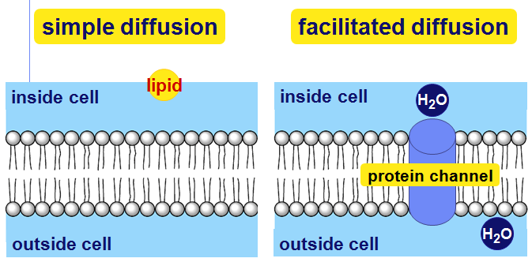
Diffusion
Move from ___________ to _________ concentration
- ______________________________
- ______________________________

Simple Diffusion
- Move from ________ to ________

Facilitated Diffusion
- Move from ________ to ________ through a _____________

Diffusion (summary)
Move from ______ to ______ concentration
- Directly through the ____________
  - ___________________________
  - ___________________________
- Help through a ____________________________
  - _________________________ (with help)
  - _________________________

Active Transport
Cells may need molecules to move _________ concentration “hill”
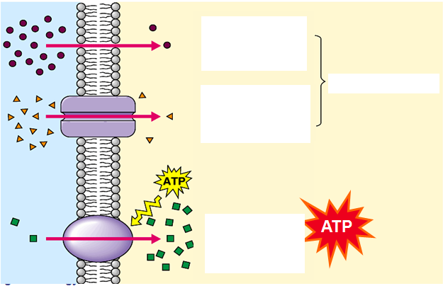
- Need to pump “uphill”
  - From _______ to ________ using energy
- ________________________
- __________________________
  - ________

