Assignment:_____
Name:______________________________________ Hour:_____
Naming Ionic Compounds
Reminder:

- Alkali/Alkaline Earth Metal and a Non-metal:

- Transition Metal and a Non-metal:

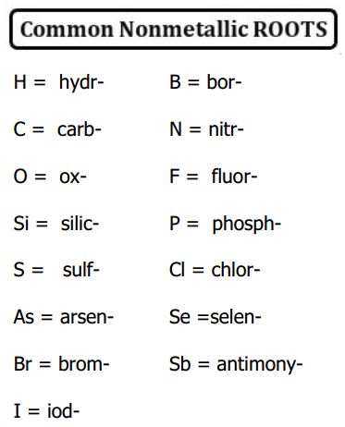
Formulas to Names for Ionic Compounds Name______________________
The general way to name a compound is to use the first element name followed by the second element with an “ide” ending or suffix. Example: NaCl = Sodium Chloride. Some atoms of transition metals have more than one possible ion. Use a Roman numeral to indicate which one is used. +1 charge = I +2 = II +3=III etc. You will need a list of common ions to complete this handout.
Name the following ionic compounds using Roman numerals where necessary.
- BaCl₂_______________________ 11. K₂S _________________________

- NaF ________________________ 12. CrCl₂ _______________________

- AgO_________________________ 13.CrCl₃_________________________

- CuBr_________________________ 14. CaO__________________________

- CuBr₂________________________ 15. Ba₃P₂________________________

- FeO_________________________ 16. Hg₂I₂________________________

- Fe₂O₃_______________________ 17. Na₂O________________________

- MgS_________________________ 18. BeS__________________________

- Al₂O₃________________________ 19. MnO_________________________

- CaI₂__________________________ 20. Mn₂O₃_______________________

