Teacher’s Notes
Creating Compounds
There are two types of compounds: Ionic and covalent
- One of the easiest ways to know which type of compound it is is by looking at what it’s made out of
Metal and Non-metal = Ionic
2 or More Non-metals = Covalent
Quick reminder…
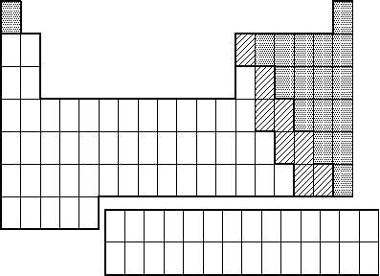
For this class we are just going to focus on ionic compounds…
Ionic Compounds are composed of ions.
- Cation – has a positive charge
- Anion – has a negative charge
*Remember opposites attract! Because an ionic compound is created out of a cation and anion they end up being neutral (having no charge). In order to be neutral the charges of each ion must cancel or balance each other out.
Video break… http://youtu.be/wWUYHHo-zB0

Let’s brush up quick on our Lewis dot structures…
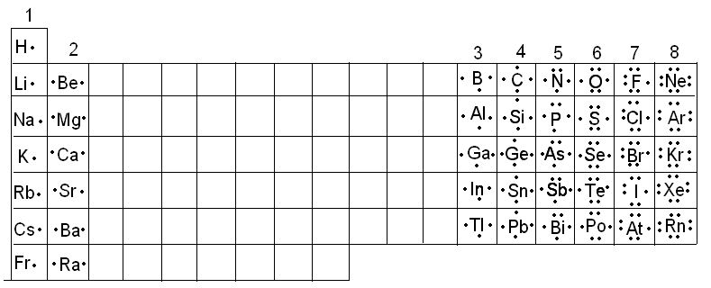
- Lewis dot structures show the outer most valence electrons only. The “magic” number is 8 to be stable (with the exception of hydrogen, who only needs 2 for its first level)
- Remind them where metals and non-metals are in general
- Based on the Lewis dots we can also easily determine charges (label them above)

So atoms want to be stable… in order to form a stable compound they must bond together with other atoms that have “needs” that complement each other.
Rules to remember…
1) Ionic Compounds always have a metal and non-metal
2) The metal is always listed first when writing out the formula

OK let’s get practicing… If I have magnesium and chlorine… what kind of compound would they make?
Step 1: Draw out the Lewis dot structures for each

Step 2: Determine what each element “wants” to do in order to be stable, in order to get that… how many of each will it need?

Step 3: Based on their wants... write out the chemical formula using subscripts to tell how many of each element are needed.

Ok… let’s take a break and watch this video to see it another way… http://youtu.be/5IJqPU11ngY
Let’s try another one… what if I have potassium and sulfur… what kind of compound would they make?
Step 1 and 2:

Step 3: What’s the compound?

Your Turn… Figure out what kind of compound the following would make, show your work below and put a box around the compound formula you come up with.
- Barium and Chlorine

- Magnesium and Oxygen

- Sodium and Sulfur

- Potassium and Sulfur

- Calcium and Oxygen

- Sodium and Bromine

- Barium and Iodine

- Potassium and Iodine

Name:_____________________________________ Assignment: 2
Creating Compounds
There are two types of compounds:
One of the easiest ways to know which type of compound it is is by looking at what it’s made out of
Metal and Non-metal =
2 or More Non-metals =
Quick reminder…

For this class we are just going to focus on ________________________…

Ionic Compounds are composed of ions.

*Remember ____________________ attract! Because an ionic compound is created out of a ___________ and _____________ they end up being __________________ (having no charge). In order to be neutral the charges of each ion must ____________________________ each other out.

Let’s brush up quick on our Lewis dot structures…

So atoms want to be ______________… in order to form a stable compound they must bond together with other atoms that have “______________” that complement each other.
Rules to remember…
1)
2)

OK let’s get practicing… If I have magnesium and chlorine… what kind of compound would they make?
Step 1: Draw out the Lewis dot structures for each

Step 2: Determine what each element “wants” to do in order to be stable, in order to get that… how many of each will it need?

Step 3: Based on their wants... write out the chemical formula using subscripts to tell how many of each element are needed.
Let’s try another one… what if I have potassium and sulfur… what kind of compound would they make?
Step 1 and 2:

Step 3: What’s the compound?

Your Turn… Figure out what kind of compound the following would make, show your work below and put a box around the compound formula you come up with.
- Barium and Chlorine

- Magnesium and Oxygen

- Sodium and Sulfur

- Potassium and Sulfur

- Calcium and Oxygen

- Sodium and Bromine

- Barium and Iodine

- Potassium and Iodine

- Francium and Oxygen

- Magnesium and Fluorine

REVIEW: More Practice Reading a Chemical Formula
Given | Mg₃(PO₄)₂ | 4Al₂(SO₄)₃ | 2Na₂SO₄
Atomic Tally | Total # of Atoms = | Total # of Atoms = | Total # of Atoms =

