Assignment:_____ Name:_______________________
Grams <-> Moles <-> Molecules
SHOW YOUR WORK!!
Notes on how to work with numbers in scientific notation like 6.02 x10²³.
-When the powers of 10 are multiplied, exponents are added; when divided, exponents are subtracted.
-Numbers expressed with powers of 10 cannot be added or subtracted directly unless the powers of 10 are the same. If they are not, you will have to move decimals and change powers of 10 until they match.
- How many molecules are there in 24 grams of FeF₃?

- How many molecules are there in 450 grams of Na₂SO₄?

- How many grams are there in 2.3 x 10²⁴ atoms of silver?

- How many grams are there in 7.4 x 10²³ molecules of AgNO₃?

- How many grams are there in 7.5 x 10²³ molecules of H₂SO₄?

- How many molecules are there in 122 grams of Cu(NO₃)₂?

- How many molecules are there in 230 grams of CoCl₂?

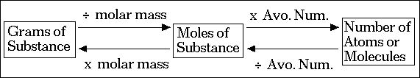
Avogadro’s Number: 6.022 X 10²³

