Assignment:____
Name:_________________________________________________________ Hour:______
Genetics – Review Sheet
Vocabulary

Meiosis
Genetics
Heredity
Pure breeding
Hybrid
Phenotype
Genotype
Homozygous
Heterozygous
Gene
Homologous Chromosomes
Mutation

Monohybrid Crosses
- What is the difference between a genotype and phenotype?
- What is the difference between being heterozygous and homozygous?
- In the heterozygous genotype, which allele masks the other?
- What does it mean to be a carrier?
- If hairy toes is dominant to un-hairy toes, show a Punnett square below that shows the cross between two heterozygous parents:
  - What is the genotypic ratio of the cross?
  - What is the phenotypic ratio of the cross?
- Use the same traits from #4, but cross parents who are heterozygous and homozygous recessive:
  - What is the genotypic ratio of the cross?
  - What is the phenotypic ratio of the cross?
- Use the same traits from #4, but cross parents who are heterozygous and homozygous dominant:
  - What is the genotypic ratio of the cross?
  - What is the phenotypic ratio of the cross?
Dihybrid Crosses (25-29)
- What is the difference between a monohybrid and dihybrid cross?
- If a parent has the following genotype, GgTt, how many different combinations of alleles could be present in its gametes?
If A is a dominant allele for blue eyes and a is recessive allele for green eyes, B is the dominant allele for tall and b Is the recessive allele for short, examine the following cross.
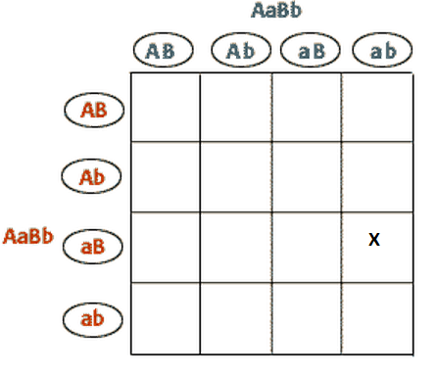
- Describe the phenotype of the parents in the cross.
- What is the phenotypic ratio of the offspring in the cross?
- What is the probability of having blue eyed short child?
Mendel’s Experiments
- Describe both of Mendel’s Laws.
Exceptions to Mendel
- Describe what is different about the following crosses and list an example of each:
  - Co-dominant
  - Incomplete Dominant
  - Multiple Alleles
  - Polygenetic
  - Sex-linked
- Who is more likely to have a sex-linked trait and why?
Mutations
- How can you “get” mutations?
- What kind of effect could mutations have on a person?
Pedigree
- How many generations are show?
- Is this autosomal or sex-linked?
- Is this dominant or recessive?
- What does it mean if the circles/squares are half shaded in?
- What does it mean if the circles/squares are totally shaded in?
- Use the letter A to fill in the genotypes of the pedigree.

