Assignment:__2__

Name:___________________________________________ Hour:_____

Fusion vs. Fission

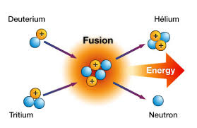
Fusion
- ______________ of 2 or more ___________ atoms into a ___________ one, _________ __________ to become more _________
- Intense heat and pressure ___________ ___________ __________________
- Happens in the ________ (____________)

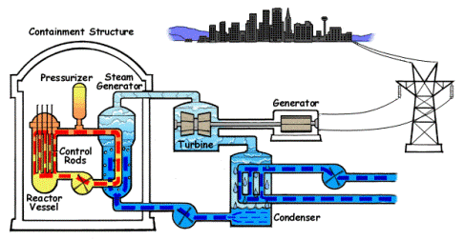
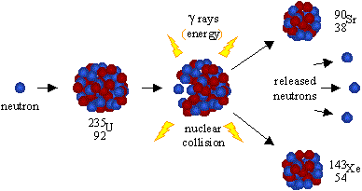
Fission
- ________________ of a ___________ atom into 2 or more ___________ ones, ______________ ____________
- __________ ______________ style… one ____________ ______ an _________, more neutrons break off… split more atoms etc.
  - A _________ __________ that causes the _______ ___________ to occur over and over
- Doesn’t normally happen in ___________
- Used in ________ _________
- Used in ____________ ____________

Nuclear Bombs
- Have been used on ______________
  - Used at the end of WWII, Little Boy (_______________) and Fat man (________________)
- Over _____________ have been tested by the ________ alone

Nuclear Power Plants
- Cadmium Control Rods – used in nuclear power plant to __________ ____________ ______ by absorbing particles needed for the chain reaction
  - If they stop working the reactor could _____________ or ________________

