Assignment: 4
Name:_____________________________________ Hour:______
Fermentation Notes and Summary
So if there is NO oxygen after Glycolysis…
Alcoholic Fermentation
- Takes ___________ and makes ____________ (_________________) and ______________ ______________
- Happens ______________ _____________ but makes very __________ ______
- Used by _______________ and ______________
OR… depends on the type of organism…
Lactic Acid Fermentation
- Takes _______________ and makes ___________ _________
  - Lactic Acid is what makes your _________________ __________
  - This is eventually __________________ down over time and removed as ____________
  - Happens ___________________ _____________ but makes very _________ _____
  - Used by __________________ and some ____________

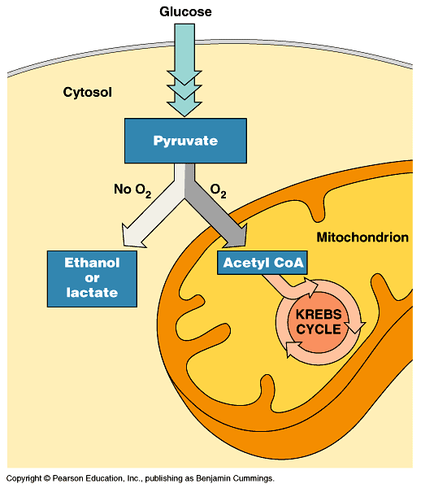

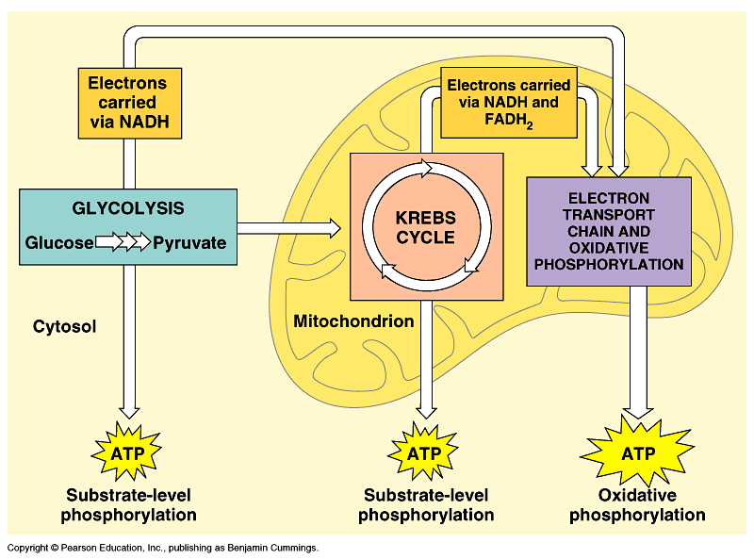
Cellular Respiration and Fermentation Summary

