**Extra Practice Radioactivity Test**

**Fill in the blanks with the correct term:**

______________________ A device used to measure radiation

______________________ A single action that causes the same reaction to occur over and over

______________________ Radioactivity that can be blocked by paper but is still dangerous

______________________ The amount of time it takes for a radioactive substance to lose half its mass

______________________ Two nuclei forced together, releasing energy

______________________ Decay of this is used to determine the age of formally living material (was isotope)

______________________ Radiation that can be blocked by wood but not paper

______________________ Emission of high energy radiation, foes through all but thick concrete and lead

______________________ The nucleus splits apart, releasing energy

______________________ Used in nuclear power plants to control reaction rate by absorbing particles

______________________ Can cause and cured cancerous cells

______________________ Is used to make foods safe to eat by filling bacteria and microorganisms

______________________ One of the first female scientists to discover radioactive isotopes

______________________ Used in medicine to follow chemical reactions inside the body

______________________ Radiation that comes from the sun, soil and building materials

**Fusion vs. Fission**

Sort the following statements into the categories below:

* Used by nuclear power plants
* The splitting of a nucleus
* The joining of two nuclei
* Used by the sun
* Used in nuclear bombs
* Release energy
* Creates stable atoms
* Creates a chain reaction once started

**Fusion**

**Both**

**Fission**

**Nuclear Power Plants**

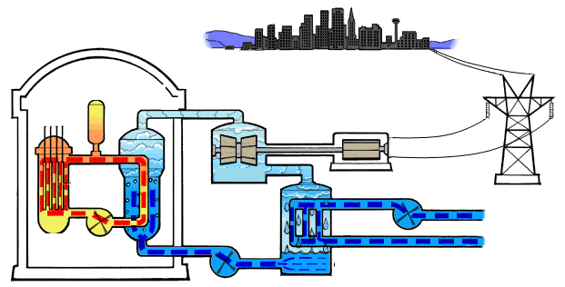

**E**

**D**

**C**

**B**

**A**

Match the following terms with the letters above:

1. Cadmium Control Rods (used to control the rate of reactions)
2. Uranium (radioactive isotope that under goes fission to release energy)
3. Turbine (turned by the steam to create electricity)
4. Cooling system (continually pumps in cool water to keep the uranium from overheating)

**Nuclear Bombs**

Briefly describe how nuclear weapons have been used by the United States.

**Half-lives Practice**

**The half live of Carbon-14 is 5,730 years, answer the following questions based off of this data.**

What is the age of a fossil with 25% C-14 left?

How much of a 240 gram sample of C-14 will be left after 4 half-lives?

How many half lives would have passed by the time a 150g sample of C-14 decays into 18.75g?

How many years does it take for a 1200g sample of C-14 to decay into a 300g sample?

What percentage of a sample of C-14 remains after 17,190 years?

**Use the graph below to answer the following questions:**



What is the half-life of barium-139?

How long would 3 half-lives be for Ba-139?

What percent would be left after 3 half-lives?

If you had 60 grams of Ba-139, how much would be left after 240 minutes?

If you had 50 grams of Ba-139, how much would be left after 4 half lives?

If you have 50% of Ba-139 left, how old would the sample be?