Extra Review Practice – Unit 6 Properties of Matter

Review Questions

- All matter has what two properties?
Mass and Volume
- What are the following changes of state called:
  - Liquid to Gas – Vaporization or melting
  - Gas to Liquid – Condensing
  - Solid to gas – Sublimation
  - Gas to solid – Deposition
  - Gas to liquid – Condensing (ooops… again)

- When you think about salt water or ocean water, what would be the solute? What would be the solvent?
Solute – salt (what gets dissolved)
Solvent – water (what does the dissolving)

- Would the following be an element, compound or mixture?
  - Water (H₂O) – Compound
  - Hydrogen – Element
  - Salt water – Mixture
  - Oxygen – Element
  - Carbon Dioxide (CO₂) – Compound
  - Ink – Mixture (Think about our lab, Did Pete Cheat?)
- Are the following physical or chemical properties?
  - Reacts with acid forming bubbles - Chemical
  - Changes to a purple color when dyed - Physical
  - Has small crystals – Physical
  - Turns red when heated – Physical
  - Is chunky and blue – Physical
  - Rusts into another substance – Chemical

Mega Matching – Match the following terms with their definitions.

__S__ A type of colloid in which a liquid or solid is suspended in a gas (like 2 chainz’s new axe like body spray)
__w - matter (oops this wasn’t on original the list!!)__ Anything that has a definite shape and volume
__P__ A type of colloid with liquid particles spread out in a solid (like hair gel)
__T__ A type of colloid with two liquids (like the lotion 2 chainz uses on his smooth skin)
__Q__ Anything that doesn’t have a definite volume and shape
__I__ A uniform mixture with the same composition throughout (like lemonade)
__H__ A heterogeneous mixture where the parts are visibly separate (like mud or paint)
__F__ A pure substance composed of elements that have been combined chemically in fixed rations (like carbon dioxide)
__G__ A heterogeneous mixture in which the particles are so small that they stay in solution (like non-expired milk)
__J__ A mixture that is not uniform throughout (like a pizza)
__M__ A homogeneous mixture made of a solute and solvent
__N__ The material in a solution that is dissolved in the solvent
__O__ The material in a solution in which the solute is dissolved
__L__ A change in matter that does not produce a new kind of molecule
__K__ A change that produces new chemicals with new properties
__x - mixture (oops wasn’t on the original list either!!)__ A type of substance that contains two or more components that can be separated by physical means
__V__ A pure substance made of only one kind of atom
__D__ A solution that can still dissolve more solute
__E__ When a liquid becomes a solid
__C__ A solution that has the maximum amount of solute that can dissolve in the solvent
__A__ A solution that contains more solute at a certain temperature than it would normally be able to hold
__B__ The maximum amount of solute that can be dissolved in 100 grams of solvent at a certain temperature and pressure.

- Supersaturated Solution
- Solubility
- Saturated Solution
- Unsaturated solution
- Freezing
- Compound
- Colloid
- Suspension
- Homogeneous mixture
- Heterogeneous mixture
- Chemical change
- Physical change
- Solution
- Solute
- Solvent
- Gel
- Gas
- Solid
- Aerosol
- Emulsion
- Compound
- Element
- Matter
- Mixture

Questions Based on Graphics:

- Which picture would best show two gases that have been combined as a mixture?
D – mixtures are not chemically bonded together, so while they would both exist in the new picture they would not have rearranged their molecules
- Which picture would best show two gases that have been combined as a chemical reaction?
B – chemical reactions would rearrange the bonds, so the two types of gases and now together, however out of the three that show this C most correctly reflects the balance between the two gases

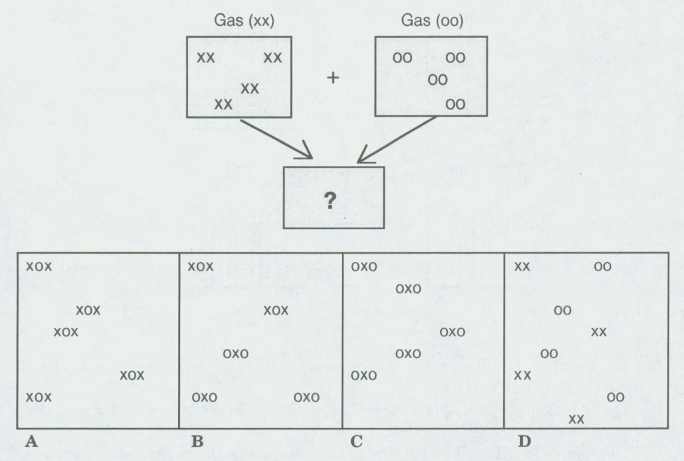

- List the states of matter seen below in order they appear:
Plasma, Solid, Gas, Liquid
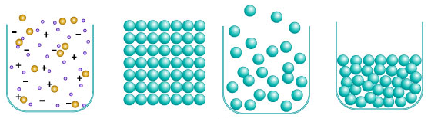
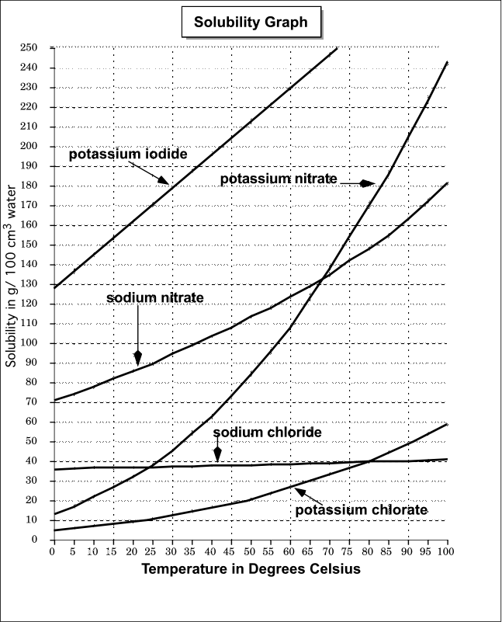
- What is the solubility of sodium nitrate in 100 cm³ of water at 50 degrees? About 120 g
- What is the solubility of potassium nitrate in 100 cm³ of water a 100 degrees? About 242 g
- Based upon the graph above as temperature _increases_ the solubility of these chemicals _increases_.

