Extra Review Practice – Unit 6 Properties of Matter

Review Questions

- All matter has what two properties?

- What are the following changes of state called:
  - Liquid to Gas –
  - Gas to Liquid –
  - Solid to gas –
  - Gas to solid –
  - Gas to liquid –

- When you think about salt water or ocean water, what would be the solute? What would be the solvent?

- Would the following be an element, compound or mixture?
  - Water (H₂O) –
  - Hydrogen –
  - Salt water –
  - Oxygen –
  - Carbon Dioxide (CO₂) –
  - Ink -
- Are the following physical or chemical properties?
  - Reacts with acid forming bubbles -
  - Changes to a purple color when dyed -
  - Has small crystals -
  - Turns red when heated -
  - Is chunky and blue –
  - Rusts into another substance -

Mega Matching – Match the following terms with their definitions.

____ A type of colloid in which a liquid or solid is suspended in a gas (like 2 chainz’s new axe like body spray)
____ Anything that has a definite shape and volume
____ A type of colloid with liquid particles spread out in a solid (like hair gel)
____ A type of colloid with two liquids (like the lotion 2 chainz uses on his smooth skin)
____ Anything that doesn’t have a definite volume and shape
____ A uniform mixture with the same composition throughout (like lemonade)
____ A heterogeneous mixture where the parts are visibly separate (like mud or paint)
____ A pure substance composed of elements that have been combined chemically in fixed rations (like carbon dioxide)
____ A heterogeneous mixture in which the particles are so small that they stay in solution (like non-expired milk)
____ A mixture that is not uniform throughout (like a pizza)
____ A homogeneous mixture made of a solute and solvent
____ The material in a solution that is dissolved in the solvent
____ The material in a solution in which the solute is dissolved
____ A change in matter that does not produce a new kind of molecule
____ A change that produces new chemicals with new properties
____ A type of substance that contains two or more components that can be separated by physical means
____ A pure substance made of only one kind of atom
____ A solution that can still dissolve more solute
____ When a liquid becomes a solid
____ A solution that has the maximum amount of solute that can dissolve in the solvent
____ A solution that contains more solute at a certain temperature than it would normally be able to hold
____ The maximum amount of solute that can be dissolved in 100 grams of solvent at a certain temperature and pressure.

- Supersaturated Solution
- Solubility
- Saturated Solution
- Unsaturated solution
- Freezing
- Compound
- Colloid
- Suspension
- Homogeneous mixture
- Heterogeneous mixture
- Chemical change
- Physical change
- Solution
- Solute
- Solvent
- Gel
- Gas
- Solid
- Aerosol
- Emulsion
- Compound
- Element
- Matter
- Mixture

Questions Based on Graphics:

- Which picture would best show two gases that have been combined as a mixture?
- Which picture would best show two gases that have been combined as a chemical reaction?

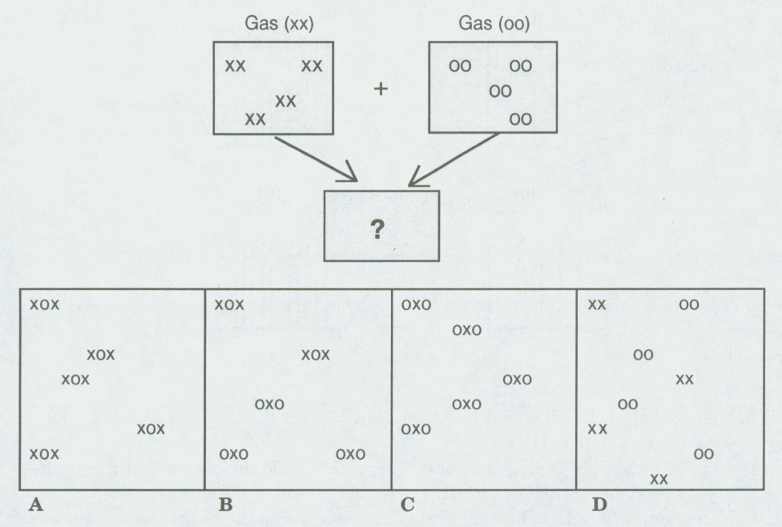

- List the states of matter seen below in order they appear:
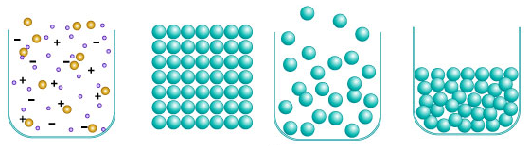
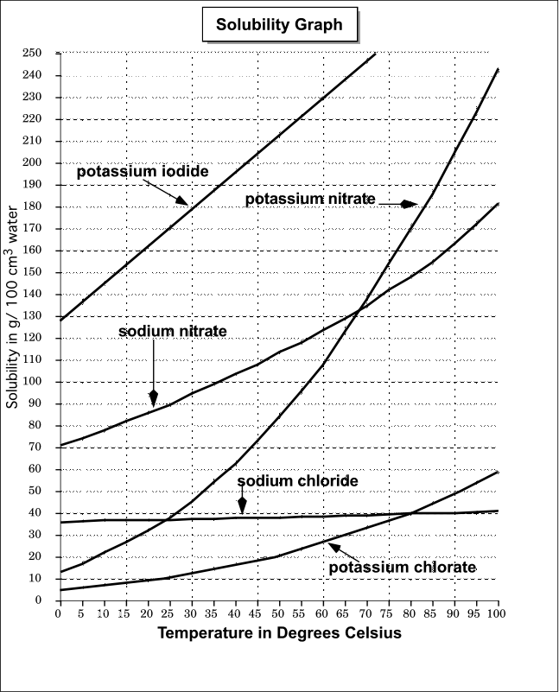
- What is the solubility of sodium nitrate in 100 cm³ of water at 50 degrees?
- What is the solubility of potassium nitrate in 100 cm³ of water a 100 degrees?
- Based upon the graph above as temperature ___________ the solubility of these chemicals __________.

