Assignment Number:_______
Name:________________________________________ Hour:______
Exceptions to Mendel - The Post Mendel Era
After the time of ____________________ we have discovered most genes are more __________________ then simply ____________________ and ___________________.
Examples: Incomplete dominance, codominance, multiple alleles
Incomplete Dominance – the ______________________ of _________ different traits in a _______________________ genotype
Example: red and white crossed making pink
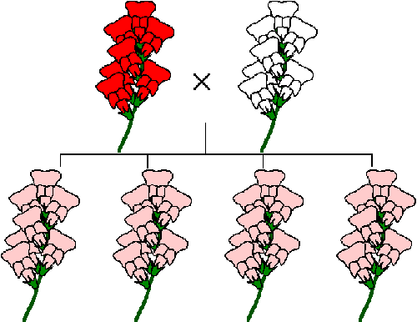
Practice Problem: If color exhibits incomplete dominance in violets, what will be the phenotypes of the offspring of a homozygous red and homozygous white plant?

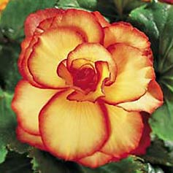
Co-dominance – in a __________________________ genotype both genes are _________ expressed
Example: yellow begonias crossed with red end up looking yellow with red edges
Practice Problem 1: Cross a cat with black fur (B) with a cat that has tan fur (b). If we assume that fur color exhibits co-dominance, what will be the phenotypes of the offspring? (Hint: black and tan fur together make a color called ‘tabby’ in cats)

Practice Problem 2: What if we wanted to get some cats that have tan fur, some with black, and some tabby? What would have to be the phenotypes of the parents?

Multiple Alleles – More then _________ alleles can exist for one trait, each individual can only have ______. This lends to more than ______________ possible genotypes.
Example: Blood type has 3 alleles that exist and there are 6 genotypes and 4 phenotypes possible.
Examples: Blood type
I^{A} I^{B} i
Above are the three possible alleles for blood type. You have a combination of two of these.
Phenotype (Blood type) Genotype

I^{A} and I^{B} are co-dominant, and i is recessive
Practice Problem #1: What are the chances of a woman with Type AB and a man with Type A having a child with Type O?

Practice Problem #2: Dr. Paul is blood type O. His father was blood type A and his mother was blood type B, what were the genotypes of his parents?

Practice Problem #3: California Court Case. Was the judge correct?
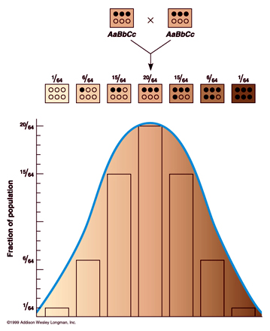

Polygenic – describes a trait that is ____________________ by ____________ than one
pair of ______________, this allows for a variety of intermediates
Examples: Human height, skin color, hair color, body build
Sex linked Inheritance – a trait that travels on the _____ chromosome, results that _______ can NOT be _______________, but women can. The only way for a woman to have a sex linked disorder is if her father has the disease and her mother either carries it or has it herself

