Name;______________________________ Assign:___
Possible Modes of Natural Selection
- __________________ leads to differences in selection
- __________________/_________________ favors the extremes over intermediates
- __________________ shifts variation toward one extreme
- __________________ leads to reduced variation/uniformity, selects against extremes
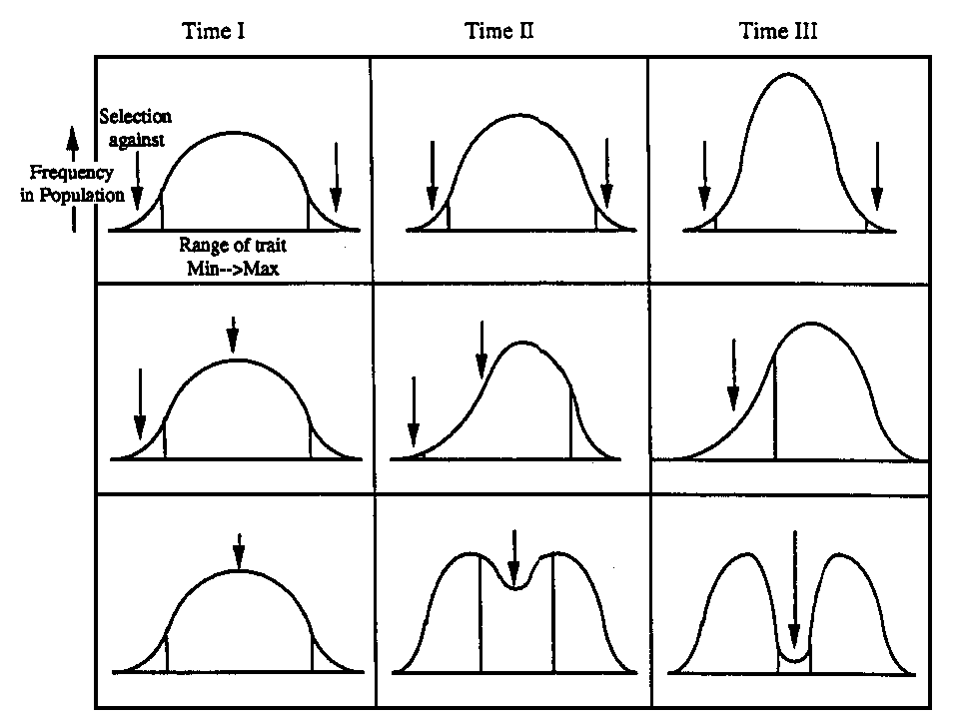
Evidence of Evolution
Fossil Record
- Fossils are more than just bones
  - __________________ ____________________
  - __________________ ____________________
- Fossils become more complex over time
- Age determined by __________________________
- _______________ has a half life of 5,730 years, other isotopes used also
  - Earth = ____years old Oldest fossils = ______years old

Fossil Record Continued
- __________________________
  - Skeletons showing animals that are similar but change over time and can be dated using carbon dating
  - Examples include
    - ____________ & ____________
_______________________________
_____________ & _________________ Patterns
- If species have changed over time then their ____________ should have changed too
- Thus more closely related species share more similar ____________ and ____________ patterns
  - E.g. 1 protein in humans in chimps is identical in all 104 amino acids. Dogs share 91/104, and rattlesnakes 84/104
Evidence of Natural Selection
- Many species and many locations where this can be seen
  - __________________ experiment by Kettlewell
    - Recreated London smog/soot effect on moth coloration.
  - __________________
    - HH = ___________, Hh = __________ but low blood oxygenation, hh = ________________
    - 1/100 people have hh in central Africa
    - 1/500 African Americans have hh in the U.S.
    - Hh = Reduced risk of ____________ but can pass disease onto children
    - In the US there is _________________ selection against sickle cell
    - In Africa there is _________________ selection
Species Formation
- ___________________ are populations of same species that differ slightly genetically to adapt to their conditions.
- ___________________ is increase in these differences over time
  - Long buildup of differences can generate new species
  - Humans races are Extremely closely related.

