Name:____________________________________ Hour;____
Enzymes
Enzymes are ___________________
Catalysts are _________ that ________ up ______________ ___________________
- Think of enzymes (catalysts) as the _____________ in chemical reactions
  - They are just helpers so they ___________ __________ _____________ ______
  - They are affected though by
    - _____________________ (too few or too many)
    - ______
    - ____________________
    - Salinity (________)
- They help chemical reactions by doing one of the following
  - ___________________ up the _____________________ of a molecule into _______________ parts
  - ________________ up the ______________ (building) of ___________ molecules into __________ ones
- There are three parts to an enzyme catalyzed reaction
  - ___________ (has a very specific active site where the molecules “dock”)
  - ____________
  - ____________

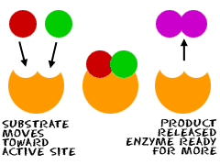
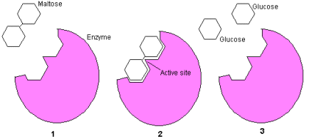

Activation Energy: the _____________ needed to ____________ a chemical reaction
- By using a catalyst you can _______________ the activation energy
