Assignment: 1
Name:_______________________________________ Hour:____
Light and the Electromagnetic Spectrum
Light is comprised of ________________.
Photons = (named by Albert Einstein) are ___________ of ___________
Light travels extremely ________
- Approximately ___________________ km/s through a _______________ (remember that different ______________ can cause light to change _______________ as it passes through them)
- Light travels much ____________ than ______________
  - Example: You see lightning before you hear the thunder
Visible Light is part of the ________________________ spectrum… therefore it is an electromagnetic _________
- Remember electromagnetic waves do ________ need a _______________ to travel through
- Electromagnetic waves travel using both the ____________ field and the ____________________ field
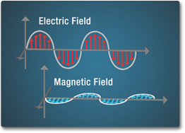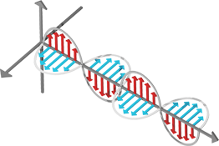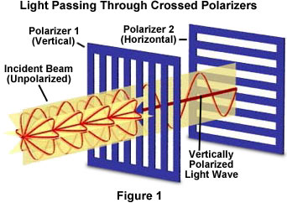
Polarized Light = Light that passes through a polarized ____________ that __________ light waves vibrating in ________________ _______________
Color
- There are three primary colors of light:
  - _________, ____________, __________
  - Note: These are _______ the same as the primary colors of paint
- The color something _____________ is due to the wavelengths it _____________ NOT what it absorbs
  - Ex: Leaves are green because the _________________ molecules ___________ wavelengths of ____________ light and __________ red and blue
- Colorblindness – the ___________ in your eyes (we will get into details of the eye later this week) are sensitive to different ____________
  - Most common form of colorblindness is _________________
    - Affects about ___ of every ____ ___________
    - Affects ______ more often than women as it is an ___ chromosome sex linked trait

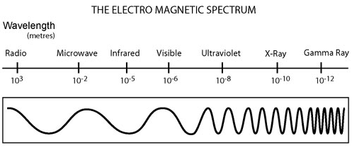
After you have taken the quiz and used Google on some of your answers, jot down notes about the different parts of the electromagnetic spectrum that you missed during the presentations. (Hint: If it was on the quiz… it will most likely be on the mini test for this unit!)
Topic: | Additional Notes:
Radio
Microwaves
Infrared
Visible
Ultra Violet (UV)
X-ray
Gamma Rays
Lasers
Television

