Name:___________________ Assign: 2

Carbon compounds can take on all three states of matter. The number of carbons in the compound can determine the state of matter it exists in.

Name | # of Carbon Atoms | Uses
Methane | 1 | Fuel in electrical generation. Produces least about of carbon dioxide.
Ethane | 2 | Used in the production of ethylene, which is utilized in various chemical applications.
Propane | 3 | Generally used for heating and cooking
Butane | 4 | Generally used in lighters and in aerosol cans
Pentane | 5 | Can be used as solvents in the laboratory and in the production of polystyrene.
Hexane | 6 | Used to produce in glue for shoes, leather products, and in roofing
Heptane | 7 | The major component of gasoline
Octane | 8 | An additive to gasoline that reduces knock, particularly in its branched forms
Nonane | 9 | The component of fuel, particularly diesel
Decane | 10 | A component of gasoline, but generally more important in jet fuel and diesel

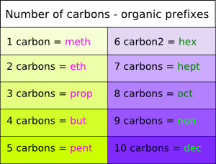

Name the following alkanes. Next to name label as a solid, liquid, or gas

- C-C-C-C

- C-C-C-C-C-C

- C-C-C-C-C-C-C-C-C-C

- C

- C-C-C

- C-C-C-C-C

Draw the following alkanes. Next to name label as a solid, liquid, or gas

- Ethane

- Butane

- Pentane

- Heptane

- Nonane

Draw the following alkenes and alkynes:

- Oct-2-ene

- Prop-1-yne

- Dec-3-ene

- Hex-1-yne

- But-2-ene

Draw the structure of the following:

- 2-methyl pentane

- 3-methyl hexane

- 4-ethyl octane

- 4-propyl octane

- 4-propyl pentane

