Assignment: 3
Name:________________________________________ Hour:____
DNA Structure and Replication Review
- Where is DNA found?
- What is DNA made out of?
- What are the four bases found in DNA?
- Which bases pair together?
- What is the structure of DNA called?
- Draw and label a nucleotide below:
- What is the complementary strand to the sequences below?
  - CCGTAG b. ATGGTA c. GCTAAT

- What does it mean when I say the strands are “complementary”?
- What is a gene?
- Why do different cells in the body differ if they all have the same DNA?
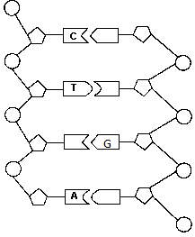
Use the picture to the left to accomplish the following tasks:
- Label a phosphate
- Label a sugar
- Fill in the letters on the bases that are blank
- Put a square around 1 nucleotide

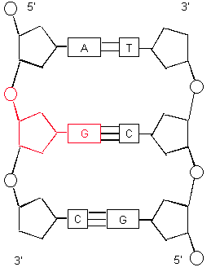
- When looking at the picture to the right, what do you notice about the hydrogen bonds between adenine and thymine vs. the ones between guanine and cytosine?

- Based on your answer above, why do you think adenine will only want to both with thymine and guanine will only want to bond with cytosine?

- What is the purpose of DNA replication?
- Describe (in your own words) the steps of DNA replication briefly.

DNA Structure Timeline Assignments
Vocabulary
X-ray crystalography transforming principal nitrogen (DNA) bases
Chargaff’s rules bacteriophage double helix
smooth (S) rough (R) qualitative test
chemical analysis enzymes

TimeLine
Create a timeline in chronological order for the following groups of scientists. Make sure you use all of the vocabulary above and underline it in your timeline. Include for full credit the 1) scientists name, 2) what they experimented on with relevant vocabulary, 3) what they discovered, 4) the date, and a 5) descriptive picture. The first one is given.

- Griffith
- Worked with pneumonia bacteria and rats
- Discovered transforming principal where bacteria pick up foreign DNA and gain those characteristics. Rough bacteria which were harmless could gain the deadliness of smooth.
- 1928
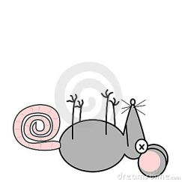

Griffith Watson & Crick Avery
Franklin (1951) Hershey & Chase Chargaff

