DNA Replication and Mutation Notes
Replication: The process of__________________ (____________) _____
This must take place ________________ cell division.
Why is there DNA replication?
One copy will power the ________________ cell, the other will be for the _______ cell.
Remember: DNA is made out of _______ strands. They are complementary to each other (bases on one strand determines the sequence on the other)
Base Pairs:
Adenine ( ) – Thymine ( ) Guanine ( ) – Cytosine ( )
Practice Strand: G A C T C G A T C C G G
Examples: #1 –
#2 -
Steps in Replication:
- ___________________ unwinds the DNA (like a zipper unzipping) creating a replication fork, it does this by _____________________ the _____________________ bonds
- DNA polymerase adds the ____________________________ bases. The DNA polymerase travels from the _______________________ end. This is the ________________ strand.
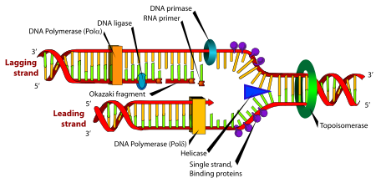
- A DNA polymerase also adds the complementary bases to the other side of the ladder, it travels in the ___________________________. It completes the strand in several fragments called _______________________. These fragments are bound together by DNA ligase. This is the _________________ strand.

Mutations
Important Vocabulary:
Codon: a series of _____ _______________________ in a DNA sequence that codes for a specific _______________ ___________
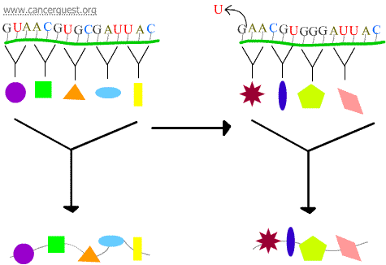
Point Mutations (gene mutations): where single genes are affected
Frameshift Mutations: The _____________ of 1 or 2 nucleotides that causes the affected codon and all of the codons that follow to be misread. This changes the protein product.
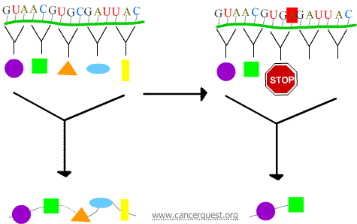
Nonsense Mutations: The new codon causes the protein to prematurely _____________, produces a shortened product.

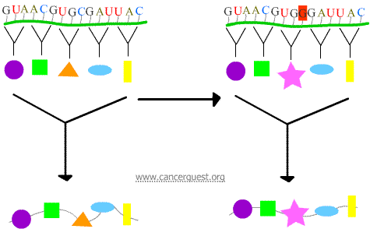
Missense Mutations: The new codon causes an __________ ____________________ to be inserted into the protein. The outcome of this depends on what is inserted in place of the normal amino acid.
Chromosome Mutations: changes in the chromosomal structure
Example Original Sequence: ABCDEFG
Translocation: ________________ of a segment from a different chromosome
Inversion: change in ________________ of a segment
Addition: the _______________ of another fragment
Deletion: the _____________ of an inner fragment
Silent Mutations: where there is a change in the DNA ____________________ HOWEVER what is expressed (_____________) does _______ change, silent mutations are there but are not __________

