Assignment:____
Name:__________________________________________ Hour:____
Why is DNA so important?
Mutation – a ________ in the sequence of DNA due to ________________ ___________ or an _________ in ___________________, _________________ or _______________________
Common Mutations
- Sickle Cell Anemia – caused by ___ being switched to ___ in the 17th nucleotide in the gene that codes for hemoglobin (so instead of coding for valine (val) it codes for glutamic acid (glu))
- Cystic Fibrosis – a single nucleotide is _________________ and it causes a _____ codon to occur to early in a gene that creates a protein that lets chloride ions through the cell membrane
- Fragile X Syndrome (causes mental retardation in males, ______) and Muscular Dystrophy (causes muscle weakness and deterioration, _____) are both caused by _______________ codon sequences
- ALS/Lou Gerhrig’s disease – caused by ___________ of “____________________” on chromosome #9
DNA Fingerprint - a _____________ ______________ of __________ that often looks like a bar code that is sometimes used to identify a parent or a criminal
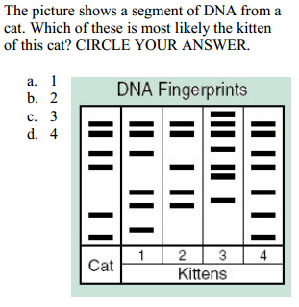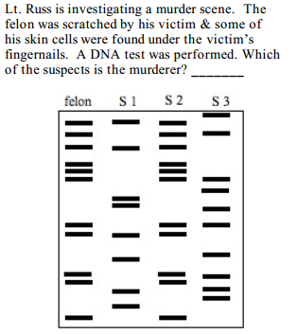
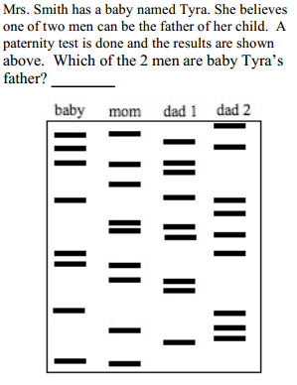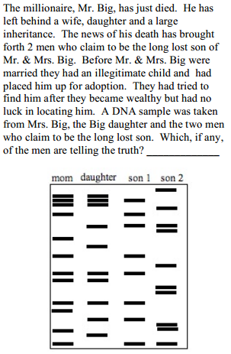

DNA References in pop music
What does Katy Perry say about DNA?

What does Lady Gaga say about DNA?

Katy Perry – E.T.
“You’re so hypnotizing
Could you be the devil? Could you be an angel?
You touch magnetizing
Feels like I am floating leaves my body glowing
They say be afraid
You’re not like the others, futuristic lover
Different DNA
They don’t understand you
You’re from a whole other world
A different dimension”
Lady Gaga – Born this Way
“Same DNA, but born this way.
Same DNA, but born this way.”

Who is accurate in their lyrics about DNA?

DNA is the ________________________ code of life – while the _______________ and the ___________ of nucleotides varies between species all living organisms have DNA made of the _______ ______________ sequence
Assignment:____
Name:__________________________________________ Hour:____
Why is DNA so important?
Mutation – a change in the sequence of DNA due to environmental damage or an error in replication, transcription or translation
Common Mutations
- Sickle Cell Anemia – caused by A being switched to T in the 17th nucleotide in the gene that codes for hemoglobin (so instead of coding for valine (val) it codes for glutamic acid (glu))
- Cystic Fibrosis – a single nucleotide is switched and it causes a stop codon to occur to early in a gene that creates a protein that lets chloride ions through the cell membrane
- Fragile X Syndrome (causes mental retardation in males, CGG) and Muscular Dystrophy (causes muscle weakness and deterioration, CTG) are both caused by repeating codon sequences
- ALS/Lou Gerhrig’s disease – caused by repeats of “GGGGCC” on chromosome #9
DNA Fingerprint - a unique patter of bands that often looks like a bar code that is sometimes used to identify a parent or a criminal

DNA References in pop music
What does Katy Perry say about DNA?

What does Lady Gaga say about DNA?

Katy Perry – E.T.
“You’re so hypnotizing
Could you be the devil? Could you be an angel?
You touch magnetizing
Feels like I am floating leaves my body glowing
They say be afraid
You’re not like the others, futuristic lover
Different DNA
They don’t understand you
You’re from a whole other world
A different dimension”
Lady Gaga – Born this Way
“Same DNA, but born this way.
Same DNA, but born this way.”

Who is accurate in their lyrics about DNA?

DNA is the UNIVERSAL code of life – while the amount and the order of nucleotides varies between species all living organisms have DNA made of the same universal sequence

