Name:_______________________________ Hour:_____
Go to pilarz.weebly.com and go under the tab KH Biology and Unit 6 – DNA and Protein Synthesis Tab. On the right hand column you will see a list of protein synthesis practice websites. VISIT THEM IN THE ORDER THEY APPEAR and complete the assignments listed below.

Website #1 Learn.Genetics
- Go to the website, click “click here to begin” and transcribe the strand of DNA to RNA and then match up the amino acids into a protein. After you have made a protein show your neighbor your screen and have them sign the line below.
Neighbor’s Name:_______________________________

Neighbor’s Signature: ____________________________
Website #2 DNA Structure
- Go to the website, explore the different tabs (concepts, animation, gallery, video, bio) and then do the problem tab. After completing the problem show your neighbor your screen it should say “congratulations, your smart” and have them sign the line below.
Neighbor’s Name:_______________________________

Neighbor’s Signature: ____________________________

- Fill in the blanks on the back of this page, detailing the parts of protein synthesis.

Name:_______________________________ Hour:_____
Go to pilarz.weebly.com and go under the tab KH Biology and Unit 6 – DNA and Protein Synthesis Tab. On the right hand column you will see a list of protein synthesis practice websites. VISIT THEM IN THE ORDER THEY APPEAR and complete the assignments listed below.

Website #1 Learn.Genetics
- Go to the website, click “click here to begin” and transcribe the strand of DNA to RNA and then match up the amino acids into a protein. After you have made a protein show your neighbor your screen and have them sign the line below.
Neighbor’s Name:_______________________________

Neighbor’s Signature: ____________________________
Website #2 DNA Structure
- Go to the website, explore the different tabs (concepts, animation, gallery, video, bio) and then do the problem tab. After completing the problem show your neighbor your screen it should say “congratulations, your smart” and have them sign the line below.
Neighbor’s Name:_______________________________

Neighbor’s Signature: ____________________________

- Fill in the blanks on the back of this page, detailing the parts of protein synthesis.
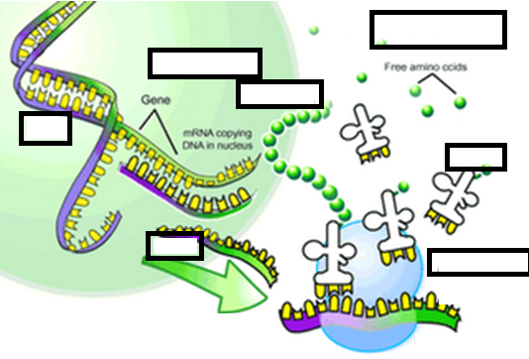
Word Bank:
Nucleus Cytoplasm tRNA DNA
mRNA Protein Ribosome
Word Bank:
Nucleus Cytoplasm tRNA DNA
mRNA Protein Ribosome

