Assignment:3
Name:____________________________________ Hour:______
Cellular Respiration – Harvesting Cellular Energy
Overview of Cellular Respiration
- ________________________ - occurs in the cytoplasm

_________________ Respiration
- Respiration _______________ O₂
- In cytoplasm
- _________ ________ Fermentation OR ______________ Fermentation
_______________ Respiration
- Respiration __________ O₂
- In mitochondria
- _____________ oxidation
- ________ cycle
- __________ ___________ _________

With or without oxygen…
Stage 1: Glycolysis
- Breaking down ______________
  - “______-_______” (splitting sugar)
  - Ancient pathway which harvest energy
    - Is the starting point for ______ cellular respiration
  - But it’s inefficient
    - Generates only _______ for every ________________
  - Occurs in ______________________
- Overview – 10 reactions
  - Convert ______________________ to ___________________________
  - Produces ___________ & _____________
  - Uses __________
  - End result: ___________& _____________
If there is oxygen…
Stage 2 & 3: Oxidation of Pyruvate and Krebs Cycle
Mitochondria – Structure
- Double membrane energy harvest organelle
  - Smooth __________ membrane
  - Highly ___________ inner membrane
    - Cristae
  - ______________________ _______________
    - Fluid-filled space between membranes
  - ________________
    - Inner fluid-filled space
Oxidation of Pyruvate
- Pyruvate enters mitochondrial matrix
  - As it enters…
    - Breaks off a ________ and makes 2 _________
    - Makes 2 _________
    - Produces 2 ___________ _______ molecules
  - Acetyl CoA enters _________ _______________
Krebs Cycle
- So we fully broke down glucose _________________ __________ & ended up with ___ _________ ______!
- Krebs cycle produces large quantities of _____________ ____________
  - __________
  - ____________
  - Go to ________________ ________________ ______________!
- Net gain = 2 _______, 8 _____________ and 2 ___________
Stage 4: Electron Transport Chain
ATP accounting so far…
- Glycolysis ___ ATP
- Kreb’s Cycle ___ ATP
- Life takes a lot of energy to run, need to extract more energy that ___ _____!
Electron Transport Chain
- Series of proteins built into_________ ______________________ ___________________
- Transport of electrons down ETC that bring _____________ ions ________ the _____________
- These hydrogen electrons fuel a protein that makes ______
- This stage make ___________ from 1 glucose!
- Only happens WITH _____ (____________ ___________________)
- As _______ and __________ move through the _____________, they drop off ___________ and make _________
We did it!
- Set up a _____ gradient
- They want to move from ________ to ________
- As they move to low the ___________ flow through ATP synthase
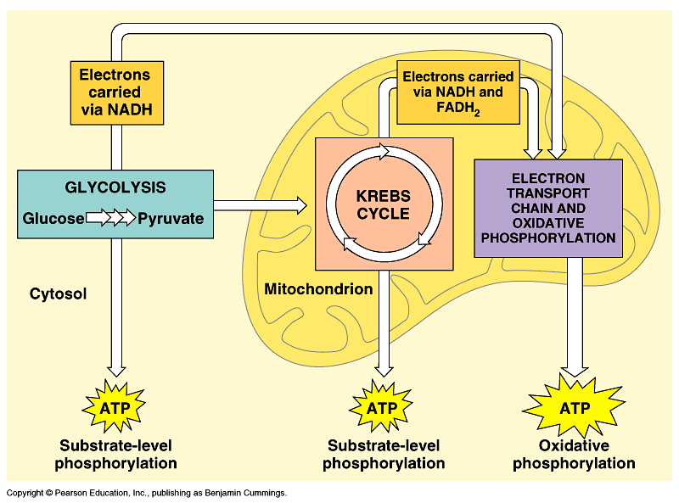
- ______________ ATP

