Assignment: 1
Name:____________________________________________ Hour:____________
Cell Basics and Plant Cells
Cell – the smallest unit that can perform all life processes
C ell Theory
- All living things are made up of one or more cells
- Cells are the basic units of structure and function in organisms
- All cells arise from existing cells
Two types of Cells
- Prokaryotic Cells – bacteria and other single celled organisms
  - Has only a single loop of DNA (that is not membrane bound), ribosomes and enzymes that are in cytoplasm, NO NUCLEUS
  - Have a cell wall around the cell membrane, some also have a capsule that allows them to cling to things
  - Examples: Bacteria and cyanobacteria
- Eukaryotic Cells – are in organisms that are made up of one or more cells
  - They are more complex so they can carry out more specialized functions than prokaryotic cells
  - Two different types: plant and animal cells
Plant and Animal Cells
Organelles – a structure that carries out a specific activities inside the cell
Cell Membrane – Is responsible for the controlled entry and exit of molecules, “the gate keeper”, found on ALL cells
Cell Wall – provides and maintains the shape of cells and serves as a protective barrier, made of cellulose
Nucleus – the cell’s internal compartment for the DNA, controls all the cell’s functions
Contains chromosomes – the structure of DNA that carries the genes and functions of the cell
Cytoplasm – inside of the cell, liquid environment that provides support for the cell, “cell jello”
Ribosomes – serves as a site to make proteins, protein synthesis occurs here “protein factory”
Chloroplast – contains the plant cell’s chlorophyll, produces food by turning sunlight into food (glucose) “food factory”
Cytoskeleton – helps maintain the cell shape, motility and internal movement “framework”
Endoplasmic Reticulum –
Rough ER – helps make proteins with the help of ribosomes
Smooth ER – helps make lipid and membrane proteins
Golgi Bodies (Apparatus)– important for packaging macromolecules for transport and delivering things around the cell “UPS store”
Vacuole –helps with digestion in the cell, is used to store water and nutrients, it helps plants keep their osmotic pressure, “storage locker”
Mitochondria – provide the energy a cell needs, produces ATP from glucose, “powerhouse of the cell”, “mighty mitochondria”
Lysomes – digest things inside the cell, “garage disposal”

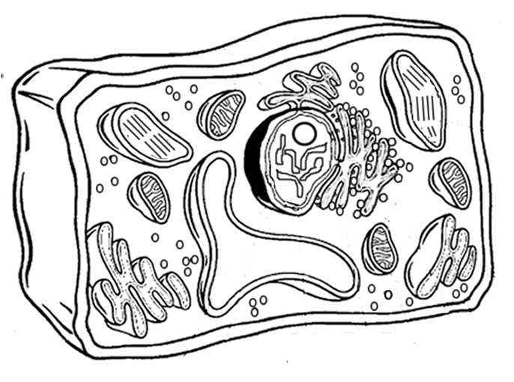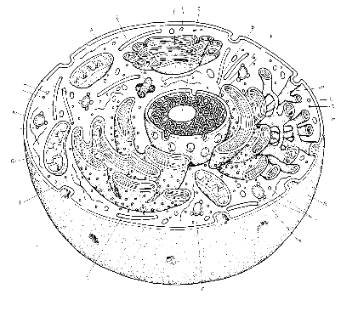
Compare/Contrast:

Assignment: 1
Name:____________________________________________ Hour:____________
Cell Basics and Plant Cells
Cell – the smallest unit that can perform all life processes
C ell Theory

Two types of Cells
- Prokaryotic Cells – bacteria and other single celled organisms
  - Has only a single loop of _______ (that is not membrane bound), ______________ and _____________ that are in ________________, ___ __________________
  - Have a cell _________ around the cell ______________, some also have a __________ that allows them to cling to things
  - Examples: ______________ and cyanobacteria
- Eukaryotic Cells – are in organisms that are made up of one or more cells
  - They are more ________________ so they can carry out more _______________ _____________ than prokaryotic cells
  - Two different types: __________ and _____________ cells
Plant and Animal Cell Organelles
Organelles – __________________________________________________________________________
Cell Membrane – Is responsible for the controlled ________ and _________ of ________________, “_______________________”, found on _____ cells
Cell Wall – provides and maintains the _________ of cells and serves as a _______________ _________, made of _________________
Nucleus – the cell’s internal compartment for the ____________, controls all the _________ _____________
Contains _________________ – the structure of DNA that carries the genes and functions of the cell
Cytoplasm – inside of the cell, _______ ___________________ that provides ________ for the cell, “______”
Ribosomes – serves as a site to make __________, ___________ ______________ occurs here “______________________”
Chloroplast – contains the plant cell’s chlorophyll, produces ________ by turning _____________ into food (______________) “_______________________________”
Cytoskeleton – helps maintain the cell __________, motility and internal movement “___________________”
Endoplasmic Reticulum –
Rough ER – helps make ____________ with the help of ______________
Smooth ER – helps make __________ and membrane _________________
Golgi Bodies (Apparatus)– important for _______________ macromolecules for ______________ and ________________________ things around the cell “_______________”
Vacuole –helps with ________________ in the cell, is used to ________ _________ and ___________, it helps plants keep their _______________ pressure, “___________________________”
Mitochondria – provide the ________ a cell needs, produces ______ from _____________, “__________________________”, “____________________________”
Lysomes – __________ things inside the cell, “______________________________”

Compare/Contrast:

