Name:______________________________________ Hour:_____
Exam Study Guide – Biology – Second Semester
Unit 1 – DNA/Protein Synthesis
Terms to know:
Biology DNA RNA Transcription Translation
Replication DNA Polymerase RNA Polymerase Ribosome mRNA
tRNA rRNA Nucleus DNA Fingerprint Deoxyribose
Ribose
- DNA is made of nucleotides, draw and label a nucleotide below.

- Describe the shape of DNA.
- How does DNA differ between prokaryotic and eukaryotic cells?
- How did the following scientists play a role in discovering the shape of DNA?
  - Rosalind Franklin
  - Watson and Crick
- Briefly describe the steps of DNA replication.
- Create a chart below comparing and contrasting DNA and RNA.
- What is a DNA fingerprint? How do we use them?
- Briefly describe the steps of protein synthesis below.
- Describe what the three types of RNA do.
- Create a diagram connecting the following things: DNA, Protein, RNA, transcription, translation, and replication.

Unit 2 – Genetics
Terms to know:
Genotype Phenotype Gametes Diploid Haploid
Homozygous Heterozygous Carrier Mutation Gene pool
Protein Chromosome Homologous chromosome Down Syndrome
Monohybrid Dihybrid Law of segregation Law of independent assortment
- What did Mendel experiment with? What were the two laws he discovered? Describe them.
- What is the difference between a genotype and a phenotype?
- Describe how the words dominant and recessive apply to alleles.
- What does it mean to be homozygous or heterozygous?
- What does it mean to be a carrier?
- What is the difference between a monohybrid and dihybrid cross?
- What does it mean if a gene is sex linked? Who is more likely to have a sex linked disorder? Why?
- If round is dominant to wrinkled, set up a Punnett square between two parents who are both heterozygous. What percent chance do they have of their offspring being wrinkled?
- If round is dominant to wrinkled, set up a Punnett square between two parents one of which is wrinkled and the other heterozygous. What percent chance do they have of their offspring being wrinkled?
- If round is dominant to wrinkled, set up a Punnett square between two parents one of which whom is homozygous for round and the other heterozygous. What percent chance do they have of their offspring being wrinkled?
- If colorblindness is sex linked, X-linked, and a father who is color blind has children with a wife that is not color blind or a carrier, what chance do their daughters have of being color blind? What about their sons?
- If 125 people are short out of 500, what is the probability of being short?
- Let’s say height followed a simple dominant/recessive pattern and both of Ms. Pilarz’s parents are tall… how is it possible she is short?
- What is the difference between a diploid and haploid cell? How many chromosomes do humans have in each type of cell?
- What is an example of a haploid cell in humans?
- What sex chromosomes do males have? What about females?
- What is a mutation? What does it cause?
- What is a gene pool?

Unit 3 – Evolution
Terms to know:
Natural selection Evolution Species Speciation Darwin
Sedimentary rocks Fossil Carbon dating (C-14) Vestigial Homologous
Phylogenetic tree Divergent Convergent Stabilizing Disruptive
Competition Mutations Geographic isolation Reproductive isolation
- Why do we say evolution is a theory?
- How did Darwin play a role in our understanding of evolution? Where did he go? What did he do?
- What is natural selection? What are the four ideas it is based upon?
- What is a mutation? Why are they so important in evolution?
- How can competition play a role in evolution?
- What is a homologous structure? Give examples.
- What is a vestigial structure? Give examples.
- What do homologous and vestigial structures tell us?
- What is a phylogenic tree? Draw an example.
- What is geographic isolation? Describe an example.

- How old is the earth thought to be? How old is the oldest fossil we’ve discovered?
Unit 4 – Infectious Diseases
Terms to know:
Pathogen Virus Bacteria Antibiotics Vaccine
- What is a pathogen?

- How does a virus infect a cell, describe how they reproduce.
- How are viruses spread between people?
- How can we sometimes prevent getting sick from viruses?
- Viruses attack specific cells or systems in the body, what system does HIV attack?
- What do we use to treat bacterial infections? Why does it not always work?

Unit 5 – Ecology
Terms to know:
Ecology Niche Abiotic Biotic Species
Population Community Ecosystem Biome Autotroph
Heterotroph Succession Symbiosis Mutualism Commenslism
Parasitism Competition Nutrients Herbivore Carnivore
Omnivore Producer Consumer Food web Food chain
Exponential growth Logistic growth Carbon cycle Nitrogen cycle Nitrogen fixing bacteria
- Define ecology.
- What is a niche?
- What is the difference between a biotic and an abiotic factor? Name examples of each.
- What is symbiosis?
- Describe an example of the following relationships:
  - Competition -
  - Mutualism -
  - Commensalism -
  - Parasitism –
  - Predator/Prey –
- What is the difference between a autotrophs and heterotrophs?
- How is the flow of energy different than the flow of nutrients in an ecosystem?
- What is succession?
- What is an example of the following:

  - Primary succession –
  - Secondary succession –
- Using the ecological pyramid below…
  - label the following: primary producer, primary consumer, secondary consumer, autotroph, heterotroph, herbivore, carnivore
  - Who is the most efficient source of energy? Who is the least?
  - If the giraffes have 100 kJ of energy, how much does the lion have? What about the trees?
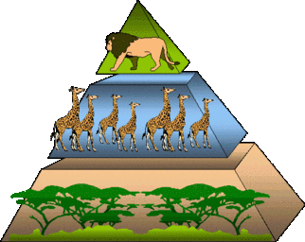

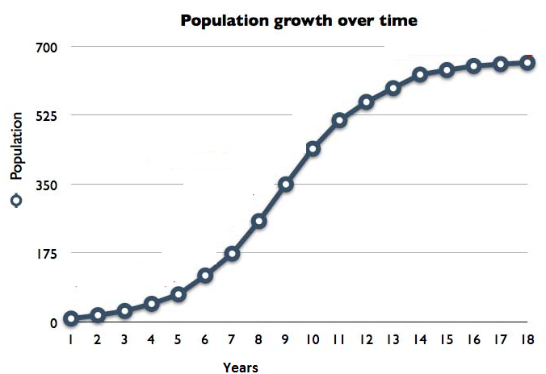
- What is the difference between a food web and a food chain?
- Answer the following questions based on the graph:
  - During what years did the population show exponential growth?
  - During what years did the population’s growth slow way down?
  - What would you estimate the population’s carrying capacity to be?

- Describe briefly the following biomes:
  - Deciduous forest –
  - Tundra –
  - Savanna –

