Name__________________________________
Chapter
21
Acids, Bases, and pH

Extending Science Concepts

Determining the pH of Acid Rain

In doing research about acid rain, scientists must often measure the pH of lakes and streams in regions far away from their laboratories. Unfortunately, pH meters require electricity. While battery packs can be used to supply the power needed to operate the meters, the packs are often very heavy. Therefore, scientists in the field are sometimes forced to use acid-base indicators to determine the acidity of remote bodies of water.

The diagrams show the color change of four commonly used indicators—methyl red, bromothymol blue, phenolphthalein, and universal indicator. The pH of each solution is indicated below the beaker.
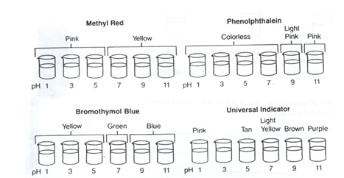

- Directions
Use the diagrams above to determine the approximate pH of water from the lakes tested in samples1-4. Each water sample shown is tested by each of the four indicators shown in the diagrams. The order of the test is, from left to right, methyl red, bromothymol blue, phenolphthalein, and universal indicator. Write the approximate pH of each solution on the right, next to the diagrams.
(Remember: Acid = a pH below 7)
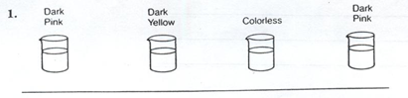

- Directions
Use the information above to answer the following questions.

- Which lakes were acidic? If normal rain has a pH of 5.6, which lakes were probably contaminated by acid rain?

- If limestone dissolved in water causes water to be basic, which lakes might have been in contact with large amounts of limestone?

- Lakes that have a bed of limestone and calcium carbonate tend to sustain life more than those with a granite bottom. If limestone and calcium carbonate are both bases, why is this true?

Online Practice: Alien Juice Bar – Go to pilarz.weebly.com, click on KH Physical Science – Unit 10, use the button titled “Alien Juice Bar” to find the link you need to do the following questions.

1.Challenge 1 - Click the button for Challenge 1 to learn more about acids and bases.
2. Click the cup with the purple juice in it and drag it to the different liquids to check the pH. What happens to the color in each one?
Lemon Juice - _____________ Window cleaner - _____________ Water - _____________
4. Drag each liquid to the correct shelf before clicking the “Check Me” lever.
5.Click the “Test More” button under the lever. When you are finished checking all of those liquids, click the “Check Me” lever. Once you get them all correct, click the “continue” button to return to the main menu.

6.Challenge 2 - Click the button for Challenge 2 to use your knowledge of acids and bases.
Read the directions before clicking the “Start” button!
1.Tips for the Flying Cabbage ... If you are not sure if a liquid is an acid or base, click and drag the cup of cabbage juice to the bottle to test the pH. Click and drag the bottle of liquid to the clear cup in front of the alien to pour a drink.
2. How did you do? If you kept everyone alive, click the “Main Menu” button. If you didn’t keep everyone alive, click the “Try Again” button. Show your neighbor when you’ve safely made enough drinks keeping everyone alive and have then sign your paper:______________________

7.Challenge 3 - Click the button for Challenge 3 to test your knowledge of acids and bases .
1. Click and drag the cup of cabbage juice to each drink on the tray to check the pH.
2. To change the pH of a liquid, click a bottle of liquid from the shelf and drag it to a glass. Watch the pH increase or decrease.
3. If you need a lower/higher reading, keep adding acids/bases until the pH is in the correct range. Once all the drinks are correct, you will see a “Continue” button. Click it to move on to the next set of drinks. Continue adding acids and bases to the drinks until you get the pH at the correct level. HINT: For this section, neutral equals anything between 6.80 and 7.20!
4. Which acid and base caused the biggest changes in pH? (Based on one click and drag!)
5.Acid - ______________________ Base - ________________________

